Tamkang Times No.1172
Peter Hu Awarded the 2023 Future Enterprise Award for Best CIO of the Year

On October 19, Peter Hu, an alumnus from the Department of Information Management at our university and EVP& CIO of the Information and Digital Transformation Technology Division at FET, received the prestigious “Best CIO of the Year” award at the 2023 Future Enterprise Awards hosted by International Data Corporation (IDC). Hu is responsible for enterprise information service transformation, the next-generation digital user experience, digital development, and the strategic planning and implementation of FET's “大人物 (Big Data, AI, IoT)” strategy.

Hu expressed his gratitude for the recognition from the 2023 Future Enterprise Awards, which were judged by international experts from IDC. In recent years, he has taken on the dual role of CIO and CTO at FET. He has driven IT technology to facilitate digital transformation and talent development, leading to the creation of a second growth curve. In addition to the telecommunications business, he has expanded the company's growth into areas such as smart applications and telemedicine, offering value-added new services. The “FET Innovation Accelerator” has also generated opportunities for digital transformation worth billions.

Using OpenAI technology, Hu has transformed AI technology into a profit engine for his company. He pointed out that with the rapid development of AI, it can be challenging for typical businesses to specialize in the technology. To prepare for future growth, it is not only important to understand which technologies can be applied but also to have a team capable of harnessing these technologies. This way, businesses can coexist with new technologies, stay up to date, and effectively seize the opportunities and challenges of transformation in customer service.

He also praised the advanced level of digitalization at our university. Chairperson Chang and President Keh are both highly concerned with issues like net-zero sustainability. They have already promoted the learning and utilization of data quantification and AI technology among the entire faculty and staff. AI can be used to instantly monitor a company's energy consumption. Therefore, the CIO will play a critical role in the future battle for energy conservation and carbon reduction. Driving company development through data-driven decision-making is a necessary step. Hu mentioned that Tamkang University has numerous outstanding alumni in various information industries. The university's development goals are focused on “AI+SDG=∞,” aligning perfectly with the current direction of many businesses. The future looks promising.
2023/11/14

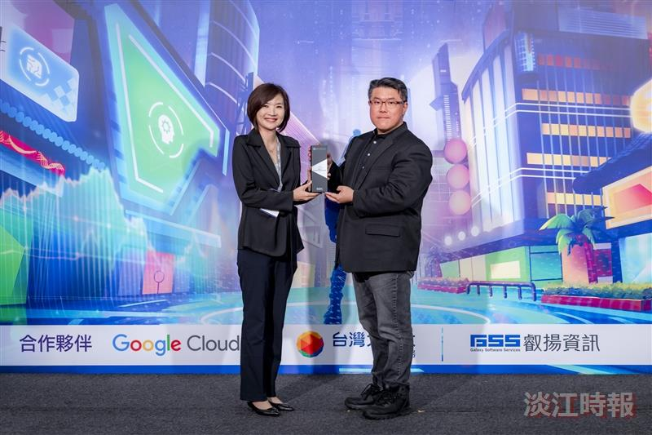
At the 2023 Future Enterprise Awards, Peter Hu, an alumnus from the Department of Information Management and EVP&CIO of FET (right), received the Best CIO of the Year.

