Tamkang Times No.986
TKU Lights up with the Christmas Spirit

【Yi-mei Chen, Tamsui Campus Report】The footsteps of Christmas joy can be heard as the winter season begins to warm our hearts with the holiday spirit. TV shows and movies also change in step with the spirit of Christmas in order to meet with the fans’ need of romantic imagery and Tamkang University is no exception when it comes to creating the Christmas vibe. Recently, large Christmas trees can be scene spread throughout the campus along with lights and colorful decorations. The students and teachers haven’t been intimidated by the cold weather as they enjoy the scenery and savor the moment taking pictures. All of these warm feelings are being made into memories in on Dec. 9, at the “Good Words and Blessed Year,” event. President Chang expressed, “For the year 2016, we are faced with difficulties involving global warming, safety and economic challenges, but no matter how the world changes, we will celebrate the 66th year of TKU joyfully.”

Director of the Office of Student Affairs, Chih-en Ko, expressed, “When we light up the lights, we also light up the spirit of the people on campus. It really builds the momentum for a great year!” The motto of the activity was simply, “Do good things, say kind words and preserve a good heart.” During the lighting of the campus ceremony, many good words were shared along with best wishes as decorations were spread throughout campus including the Innovative Center for Cultural and Creative Industries, the side of the gymnasium, the Building of Liberal arts, the Business and Management Building and more. Each intricate piece of decor is an artistic way of saying happy holidays!

In addition this event promoted a raffle that registered students using their Yo Yo card to ride the bus from Oct. 20 to Dec. 4. Participating bus lines included red 27, red 28, direct red 28, 308, and 756. Prizes that will be handed out include iPhone 6S、iPad Air2 WiFi 、Beats Studio Wireless Headset, Garmin Vivofit2 Bracelet and 0.48L ONE TOUCH. （see more raffle info at http://www.general.tku.edu.tw/enable/jindex.php）
2015/12/18

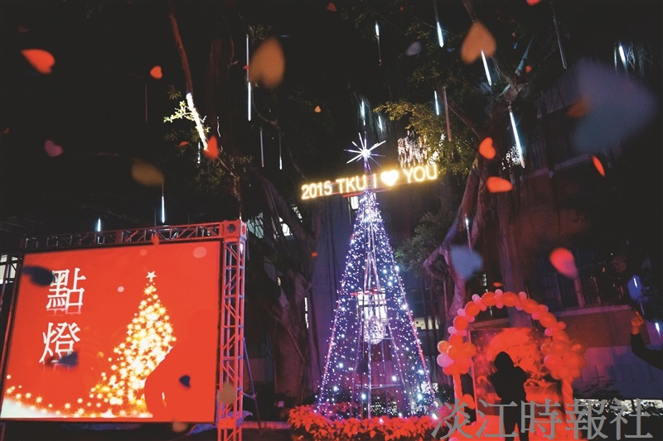
A Merry Christmas from TKU (Photographed by Wen-xing Ping)

