Tamkang Times No.985
CEMA Attends TKU Administration Meeting

【Xin-yu Wang, Tamsui Campus Report】In order to improve Tamkang University administrator’s management methods and give them a better knowledge of safety issues, Director of Chinese Excellent Management Association (CEMA) and Chairman of Taisun Enterprise Co. Kenneth Yeh-lin Chan, sent Taisun Co.’s Technical Group Produce Supervisor, Min-qin Xiao, as a representative to attend TKU’s 145th Administration meeting on Nov. 27. Taisun Enterprise Co. has been established for 65 years and is famous for many grown products including tea and porridge.

The honored guest observed the event as items were brought before the board. The meeting reviewed 5 issues including the allocation of the Ministry of Education’s subsidies for the 2016-17 academic year, water source environmental research, changes in hiring and services and the set up for the research center. After the meeting, gifts and souvenirs were given to Min-qin Xiao for his special appearance.
2015/12/11

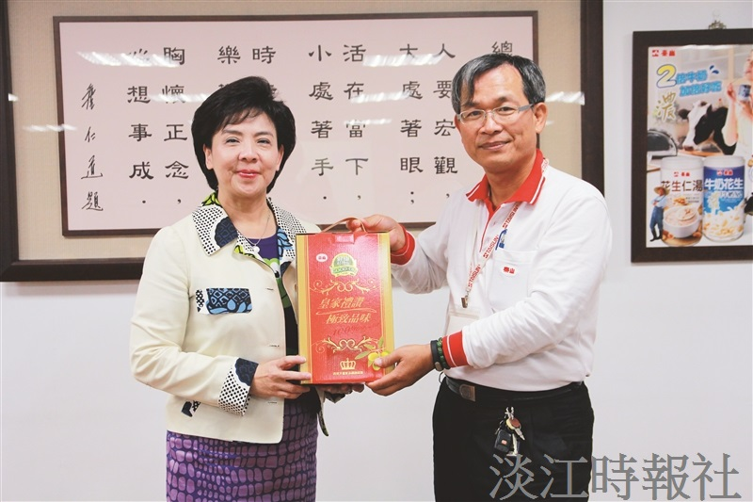
President Flora Chia-I Chang (left) and first and second level administrators invite Supervisor of Taisun Enterprises Co.’s Technical Group, Min-qin Xiao (right), to observe the meeting. (Photographed by Ling-yi Zhang)

