Tamkang Times No.981
TKU Prepares for Semi-Finals for Hult Prize

【Yu-xiang Sun, Tamsui Campus Report】This year’s 2016 Hult Prize Competition will be themed around Crowded Urban Spaces. Both Tamkang University and National Chengchi University have qualified to compete, representing Taiwan. It’s expected that the two teams of representatives will head to Hong Kong on Mar. 11 for the semi-final competition, deciding which team will be number one in Asia.

Registration for the Hult Prize Competition ends on Nov. 28 and currently there are 8 teams. Promoter of the event and fourth-year student of the Department of International Business, Xi-rui He, expressed, “I hope the people signing up for the Hult Prize contests can let the whole world know who Taiwan is. Even though this year’s champions are Chenchi University, I believe that we have the potential to take over in the future. We just have to believe in ourselves.” The final competition will be held in New York and the winning team will receive 1,000,000 dollars, receiving the winning prize from former President Clinton. (For more information see link http://www.hultprizeat.com/tamkang)
2015/11/16

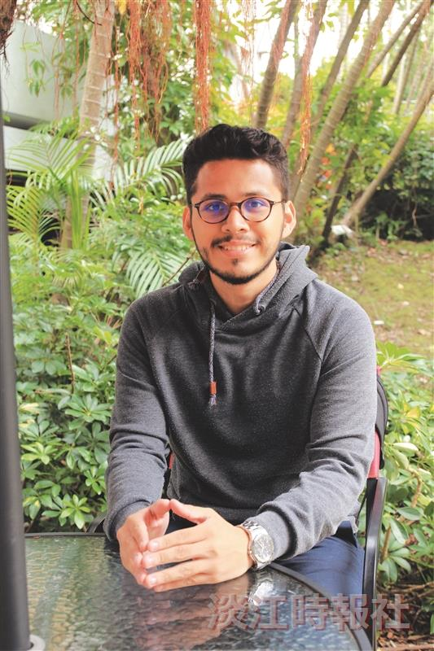
Xi-rui He of the Department of International Business is looking to TKU for the Hult Prize. (Photographed by Guo-zhen Wu)

