Tamkang Times No.981
TKU is a Hit in India, Macau and Hong Kong

【Pin-jie Chen, Shao-qi Zhang Tamsui Campus Report】From Oct. 15 to 21 the Office of Academic Affairs and the Office of International and Cross Strait Affairs travelled to India, Macau and Hong Kong for the higher learning great achievement appreciation, titled, “The 2015 India -Taiwan Higher Learning Center and Higher Learning Interview Group.” The journey left a deep impression on many overseas students as they peered into the curriculum of the Chinese Language Center, Department of Mass Communication, Department of Banking and Finance, Department of Architecture and the Department of Aerospace Engineering.

During the event there were 800 times that students inquired about TKU’s College of Business and Management, Science, Engineering and International Studies. There was a particularly heavy emphasis of inquiry on the Chinese Language Center. Yin-chu Hsin expressed, “While we were there we found that most professors and students were interested in the Chinese program. I hope this is able to attract lots of new students to come and learn.”

From Oct. 15 to 17 the 2015 Macau and Taiwan Higher Learning Development Forum attracted 4,300 people and a heavy media presence. Many parents had important questions answered about the specialties, unique traits and after graduation career prospects of TKU. Organizers of the event offered an invitation to President Flora Chia-I Chang to attend the event next year. From Oct. 30 to 31 the “2015 Yearly Hong Kong Taiwan Higher Learning Development forum took place, bringing in 12,000 participants. A large portion of the audience wanted to know more about TKU’s Department of Mass Communication, College of Business and Management, College of Foreign Languages and Literature and College of Engineering.
2015/11/16

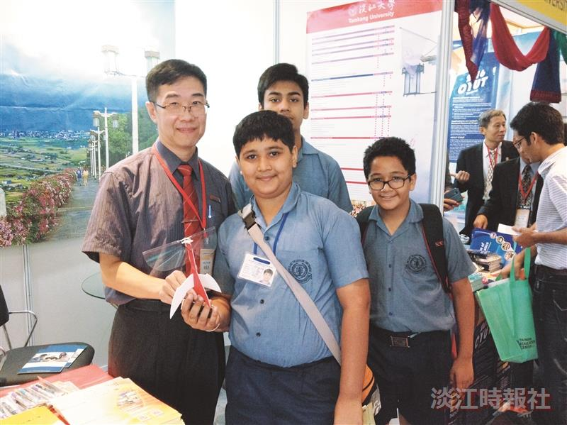
From Oct. 15 to 21 Director of Electrical and Computer Engineering, YANG LUNG-JIEH Lung-jieh Yang, headed to India for the India-Taiwan Higher Learning Center and Higher Learning Inquiry Group. (Picture provided by Admissions Section)

