Tamkang Times No.978
Malaysian TKU Alumni Honored for Success

On Aug. 15 the Federation of Alumni Association of Taiwan Universities, Malaysia (FAATUM) held their 41st Anniversary that was themed, “Passing Along the Torch - Creating New Heights of Innovation Together.” President Flora Chia-I Chang and Vice President of Administration, Yi-jen Hu, attended the ceremonial banquet. During the event, President of FAATUM and Alumni of the Department of Accounting, Ser-chong Lee, was presented with the Second Hua Guang Professional Achievement Award. Ser-chong Lee, showed his appreciation to Taiwan and for the opportunity to have an education of the spirit of excellence. (Article written by Kai-jun Lin)
2015/10/23

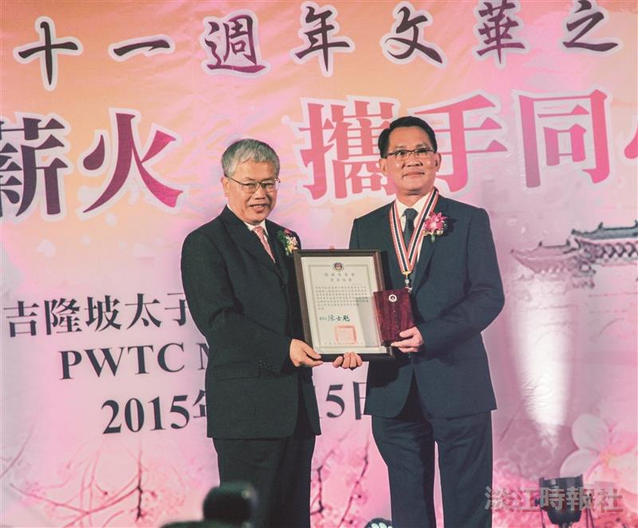
On Aug. 15 the Federation of Alumni Association of Taiwan Universities, Malaysia (FAATUM) held their 41st Anniversary that was themed, “Passing Along the Torch - Creating New Heights of Innovation Together.” President of FAATUM and Alumni of the Department of Accounting, Ser-chong Lee, was presented with the Second Hua Guang Professional Achievement Award. (Picture provided by the Office of Alumni Services and Resources Development)

