Tamkang Times No.977
TKU Analyzes Britain’s Election

【Yi-wan Lu, Tamsui Campus Report】The Office of International and Cross-Strait Affairs (OICSA) and the Graduate Institute of Future Studies held a lecture titled, “The 2015 British General election; how Labour blew it and why the clever pollsters blew it too” given by Professor of the OICSA, David Coates. The event was hosted by Vice President of International Affairs, Wan-chin Tai, Director of the College of International Studies, Kao-cheng Wang and Professor of the Graduate Institute of Future Studies, Jeanne Hoffman.

Wan-chin Tai expressed, “England’s history is quite extensive and very important in terms of the international community. Lots of international policies and laws were originated in England, which makes this event an excellent opportunity for student development and growth.” During the lecture, David Coates discussed the the participants, analyzing the failure of the Labour Party, issues with the conservative party and future trends of England’s development. Wan-chin Tai stated, “This is the first time we’ve invited an ambassador from the British Office in Taipei and I’m sure the students have gained a lot of knowledge from his years of continual research.”
2015/10/16

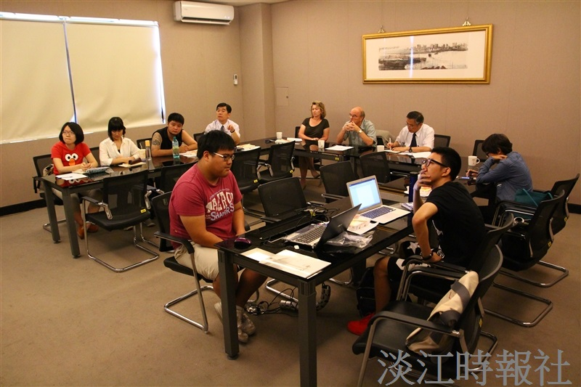
On Oct. 6 professor of the OICSA, David Coates gave a lecture titled, “The 2015 British General election; how Labour blew it and why the clever pollsters blew it too.” Vice President of International Affairs, Wan-chin Tai, Director of the College of International Studies, Kao-cheng Wang and Professor of the Graduate Institute of Future Studies, Jeanne Hoffman were also in attendance. (Photographed by Zhong-yi Wu)

