Tamkang Times No.976
TKU Architecture Department Takes Flight

【Xin-yu Wang, Tamsui Campus Report】In recent days outside of the Department of Architecture Building, many people have been asking questions about the two new planes. It turns out that 10 students of the Department of Architecture put it together in cooperation with Zhong Shan’s Institute of Science and Technology Aeronautical Systems Research Division. They also plan to create an F-100, a Shining ROC Cheihshou PL-1B, Assembly Spray Paint, and two large-scale model planes flying toward the sky in heroic fashion.

“As part of the Off-campus Internship Curriculum, before students are able to use real operational equipment, students must take a week long training course.” Said, Shuo-kai Chang, Specialist of the Department of Aerospace Engineering. “This will let students get familiar with the process of operations. I’m very appreciative to the Institute of Science and Technology Aeronautical Systems Research Division for their support.” He added. Fourth-year student of the Department of Aerospace Engineering, Guan-lin Huang, stated, “Being able to get training for the completion of a plane is not only a rare experience, but it’s a professional skill that is invaluable.”
2015/10/12

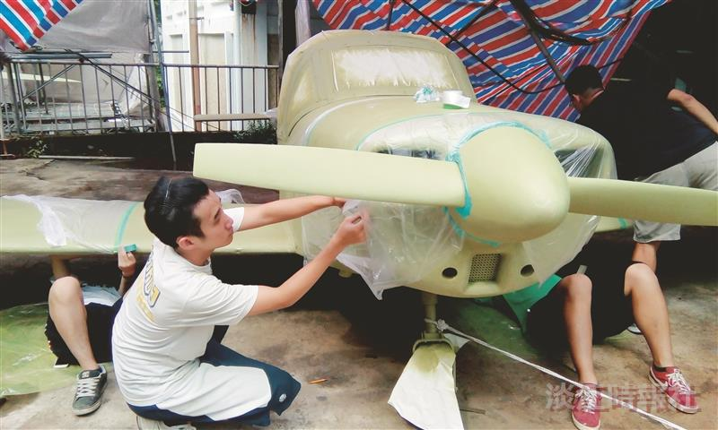
Students of the Department of Aerospace Engineering put together a plane outside their department building. (Picture provided by Department of Aerospace)

