Tamkang Times No.975
New Programs Ready TKU Students for Career World

【Jin-yu Cai, Tamsui Campus Report】In order to continue cultivating necessary career skills and applicable knowledge for TKU students in the 2015-16 school year, Tamkang University has added 6 credits worth of new programs, 2 of which are cross-major programs and the other 4 are part of an academic-industry plan. The university continues to adopt new academic programs, and as of the 2015-16 school year there are 44 programs in various fields, the most popular being Cultural Innovative Industry (376 students), Green Energy Technology (302 students) and Actuarial Science (95 students).

Another cross-major program is the Foreign Literature Foreign Diplomacy Course, which utilizes all of the Departments of the College of Foreign Languages and Literature. The objective of the course is to give students a global perspective while saturating them in a deeper understanding of the language, politics, trade and culture of another country. (For questions about the program contact ext. 2703)

Another course is Biology and Career Studies, which was created to help students cultivate usable skills for a career in science. Planning and Practical Finance is a course that is combined with the Department of Statistics and Banking and Finance that will also ensure a skill set that students can use in many industries. TKU’s continual development in cross-major and academic-industry programs continues to increase the competitive ability of future graduating students.
2015/10/02

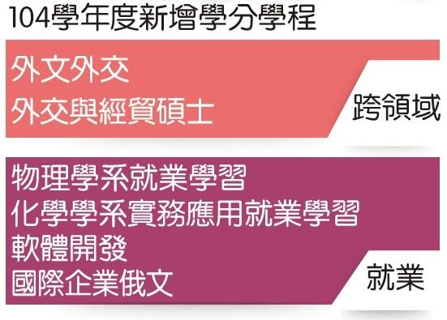
Tamkang University has added 6 credits worth of new programs, 2 of which are cross-major programs and the other 4 are part of an academic-industry plan. (Information Source: Registration Section/ Graph: Tamkang Times)

