Tamkang Times No.973
TKU Robotic Team Steals Victory for 10th Straight Year

【Yu-jin Cai, Tamsui Campus Report】Robot designs continue to modify and improve thanks to international events such as the 2015 FIRA Roboworld World Cup that took place on the 4th of August in Daejeon, Korea. In this competition the TKU robotics team outperformed the competition, winning 5 gold medals, 4 silver medals and 2 bronze medals. They won in the RoboSot Division (Robot Soccer), HuroCup (Human shaped Robots) and Medium-sized Robots Division. This is the eighth straight year for the TKU team to win the HuroCup and the 10th straight year for them to take the gold in the Medium-sized robots division.

Director of the Intelligent Automation and Robotics Center, Ching-chang Wang, expressed, “Each consecutive win adds stress to the competition, making the 10th win quite a challenge. I’m really pleased with the students as they’ve invested a lot of effort into automation research. I’m especially grateful to President Flora Chia-I Chang for all of her support, which gave us the opportunity to receive this great honor.”
2015/09/21

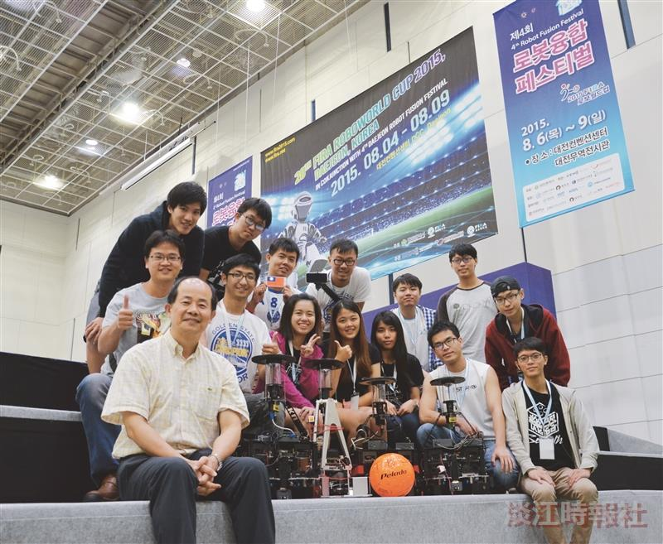
The Department of Electrical and Computer Engineering won the FIRA Roboworld World Cup that took place on August 8th. This is the 10th consecutive year winning the Medium-sized Robots Division, taking 3 gold medals and 1 silver. (Picture provided by the Department of Electrical and Computer Engineering)

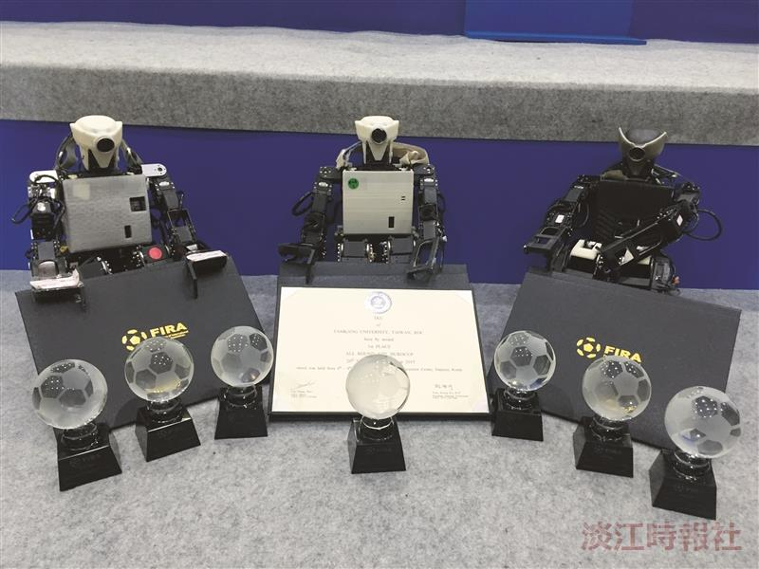
On August 4th the 2015 FIRA Roboworld World Cup that took place in Daejeon, Korea. TKU won the championship in the HuroCup overalls. The human-shaped robot division included weightlifting, climbing with weight, relay race, long-jump, basketball and the total skills event. The team won 2 gold medals, 3 silver medals and 2 bronze medals in this division. (Picture provided by the Department of Electrical and Computer Engineering)

