Tamkang Times No.971
Graduation Wishes From Chih-Chao Chuang

【Jin-yu Cai, Tamsui Campus Report】Students at Tamkang University don’t have to wear uniforms and it’s my hope that as they graduate into society that they don’t put on uniforms of a different type. Don’t forget your creativity and value and always be original and you will find true success.
2015/06/29

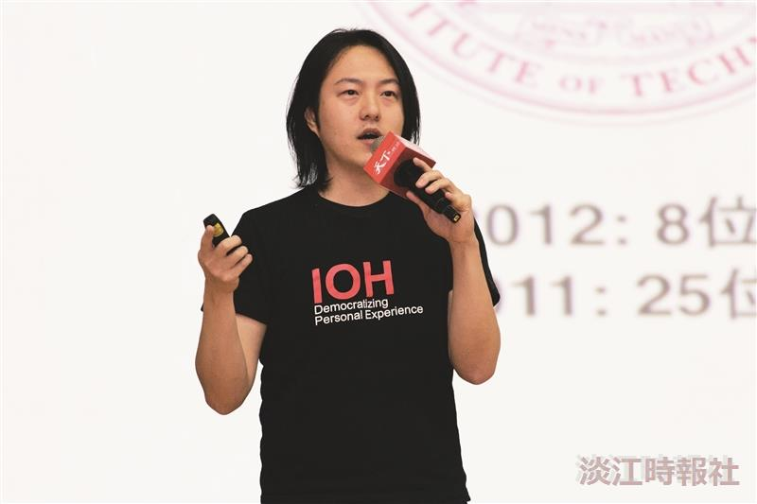
Graduation Wishes From Chih-Chao Chuang.(Photographed by Guo-en Huang)

