Tamkang Times No.970
Student Group Graduation

【Yi-ru Chen, Tamsui Campus Report】On June 11th in the Shao-mo Memorial Gymnasium, the Extracurricular Activities Guidance Section held the first Student Organization Graduation Ceremony with close to 150 student group members. Director of the Extracurricular Activities Guidance, Su-kuan Chiang, expressed, “I’m so glad to see all of the students come together for this event. It reminds me of the famous words of John Lennon, who said a dream you dream alone is only a dream, a dream you dream together is reality.”

As the event began, a documentary film was played, “Grown-up Diary”. Pictures of each group’s graduating club leaders and organizers played in a sequence with warming and relaxing music. Then student club leaders shared touching words of their memories and experience at TKU. Event Organizer, Hui-rou Li, expressed, “This event officially says farewell to the old club leaders and welcomes the new leaders to take charge.”
2015/06/22

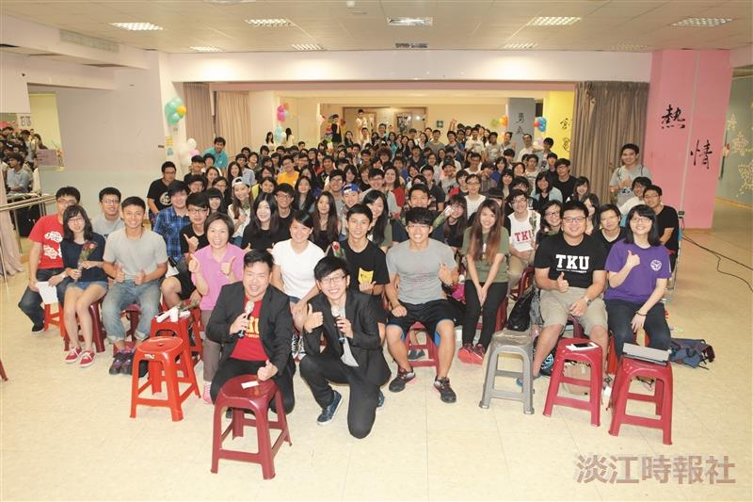
Club members gather together. (Photographed by Wei-jie He)

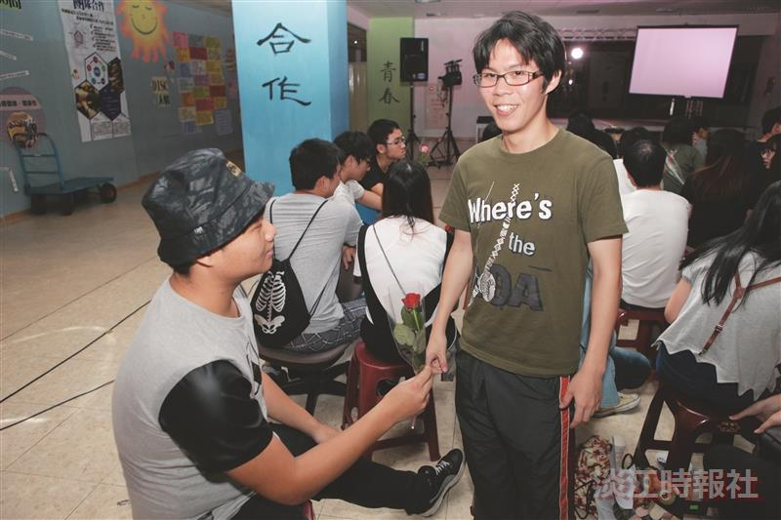
The club leaders were honored with roses. (Photographed by Wei-jian He)

