Tamkang Times No.965
The First Annual TKU Music Festival’s

【Zhao-yu Chen, Tamsui Campus Report】On May 11th the 1st Annual TKU Musical Festival will take place, held by Tamkang University Indie Hot Music Club and featuring compositions of 14 different musical groups. Leader of the TKU Indie Hot Music Club and third-year student of the Department of Industrial Economics, Zhen-zong Xu, expressed, “There are going to be many performances that represent different cultures and styles of music, but everyone shares the same love for music and sharing what they enjoy.” During the day on Hai Bao Street, students will be able to enjoy the different performances and even purchase a CD.

Also on the 13th at 10am at the Fu Yuan Japanese Garden, there will be an event held for the purpose of a lottery giveaway. The rules involve taking a picture and sharing it on Facebook to be registered in the lottery. The winning prize is an electrical guitar worth 30,000 NT!
2015/05/15

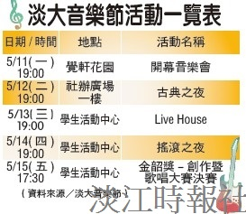
TKU Musical Festival

