Tamkang Times No.965
2015 Second Semester Sophomores, Juniors and Graduate Student Discussion

【Jin-yu Cai, Tamsui Campus Report】The 2015 Second Semester Sophomores, Juniors and Graduate Student Representatives Discussion took place on May 5th in the Chueh-sheng International Conference Hall. In attendance was Flora Chia-I Chang, Vice President of Academic Affairs, Huan-chao Keh, Vice President of Administration, Yi-jen Hu, all related administration officials and student representatives totalling around 100 participants. Lanyang Campus also attended the discussion via video conference.

During the meeting the first issue brought forward was pertaining to class selection and smoking. The related administrators answered, “All of the classes are first come first serve at the moment, but in the future it will be modified so that student needs can be met related to their particular major. We are aware it can be difficult to select certain classes because of the difficulty presented with full classrooms and student number restrictions.” Lin, a second-year student of the Graduate Institute of European Studies, asked a question regarding smoking rights and issues with second-hand smoke. Dean of the Office of General Affairs, Shiaw-shyan Luo, responded, “It’s my hope that smokers and non-smokers can have respect for each other’s rights. Twice a week we work with the office of sanitation to do an investigation related to violations of campus smoking regulations.”

Third-year student of the Department of Educational Technology, Zhang, suggested that more information be provided for student convenience. Dean of the Office of Student Affairs, Chih-en Keh, expressed that in the future there will be more signs in place to give directions and that information boards along with suggestion boxes will be in place. President Chang then expressed the concept of Total Quality Management and what that means in terms for administration members and their relationship with the students.

The International and Mainland Guidance Section held the Chinese Mainland Student Discussion on May fourth in the Chueh-sheng International Conference Hall. In attendance was President Flora Chia-I Chang, Vice President of International Affairs, Wan-chin Tai, Director of the Office of International and Cross Strait Affairs, Pei-wha Chilee and various department heads. The discussion revolved around their participation in the upcoming graduation so that they would be able to gain understanding of the program and their personal development.
2015/05/15

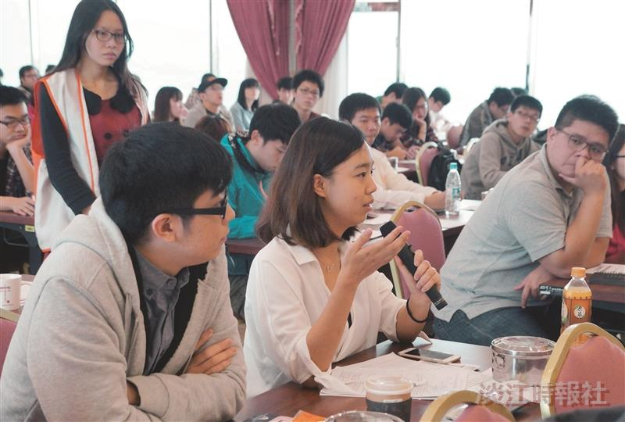
On May 5th the student representatives met with administrators for annual discussion. (Photographed by Yi-feng Lu)

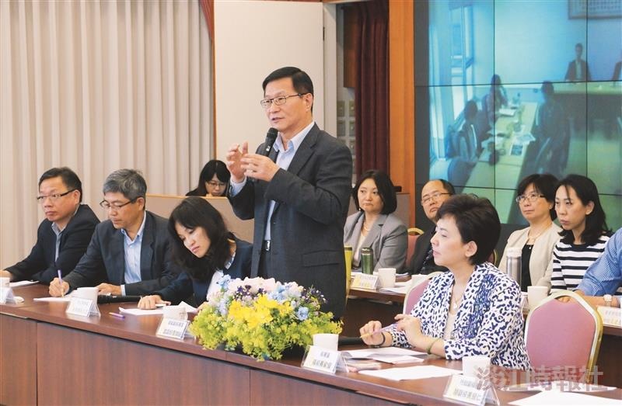
On May 5th President Flora Chia-I Chang (front row first on the right) hosted as related administration discussed with student representatives. (Photographed by Yi-feng Lu)

