Tamkang Times No.957
The Global Japan Office Project at TKU

【Reported by Yu-xuan Zhou, Tamkang Times】President of Tokyo University of Foreign Studies (TUFS), Hirotaka Tateishi, came to Tamkang University in the afternoon on March 6th for an academic exchange to present the Global Japan Office plan. President Tateishi was accompanied with 6 honored guests including the Executive Director, Yasuhisa Kanaguchi, Vice President, Kayoko Hayasi, Professor Kyoko Nomoto, Professor Jun-cheng Lin and Vice Secretary-General, Satoru Naruse, who were met by President Flora Chia-I Chang to hold the Global Japan Office ceremony in the College of Liberal Arts.

President Chang stated, “This university has always had a strong relationship with Japan and since we’ve begun our distance learning program, third-year students have been able to go to Japan for study. I’m sure that the establishment of the Global Japan Office will open up more opportunities for academic exchange.” TUFS is about 140 years old and has cultivated countless international professionals. In 2012 it was nominated as one of the Super Global Universities of the world. The Global Japan Office plan is a project between TKU and TUFS intended to strengthen the academic program involving Japanese Language and Culture while at the same time developing Japanese Language research in Taiwan.
2015/03/13

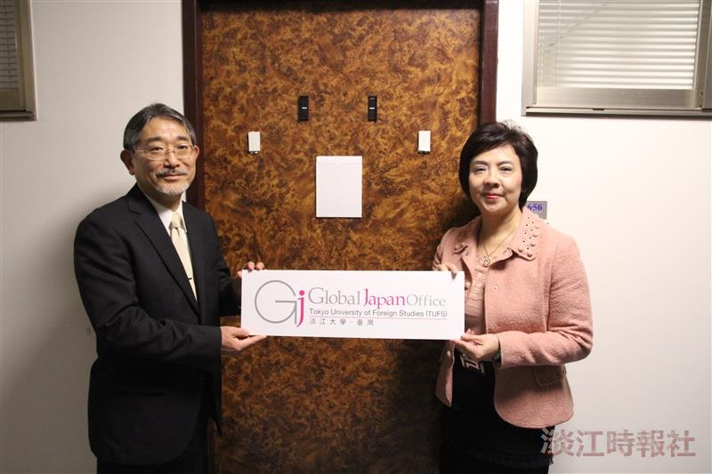
The Global Japan Office Project at TKU

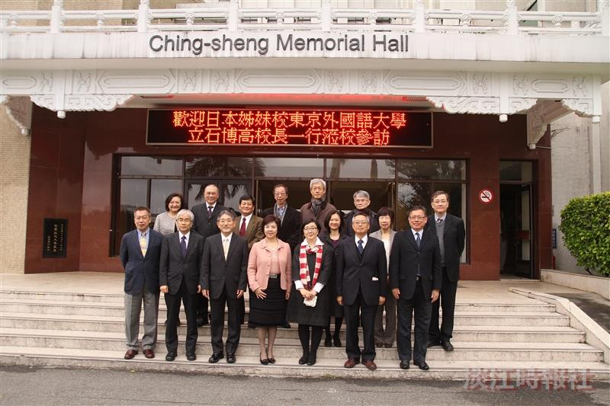
The Global Japan Office Project at TKU

