Tamkang Times No.955
Achievement Celebration Takes Place in Front of the Dormitories

【Reported by Xue-fen Ma, Tamkang Times】In order to emphasize the unique special qualities of the university, Lanyang Campus held an event showcasing the achievements on campus in the dormitories and in front of the library on December 30th. Director of Lanyang Campus, Jyh-horng Lin stated in his welcoming address, “It’s important that the spirit of excellence and good conduct transfer to more than just behavior in the classroom. By reminding ourselves to be excellent at all times, it will certainly create habits that will give students a strong future in their career.”

During the event there were dancing and singing performances that raised the energy of the atmosphere. There was a raffle and many artistic crafts that made the display of achievements even more magical. The achievements included awards for overseas study programs and recognition to every department for various accomplishments. Student from the Department of Innovative Information and Technology, Xiang-yun Chen, stated, “I think this type of event is both helpful and meaningful. It gives me a chance to focus on my goals and be grateful for this opportunity of study.”
2015/01/16

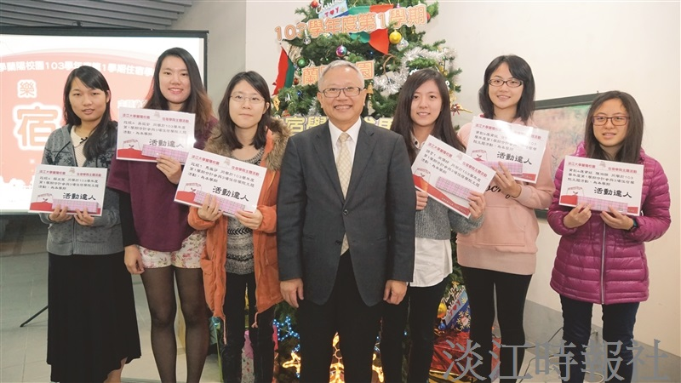
Lanyang Campus Director, Jyh-horng Lin, takes a group picture with veterans of the event. (Photographed by Xue-fen Ma)

