Tamkang Times No.955
Japanese Alumni Gang Chen Offers Services at Shihanhang Museum

【Reported by Yi-feng Lu, Tamkang Times】Alumni from the Graduate Institute of Japanese Language, Gang Chen, began working in Bali’s Shihanhang Museum of Archeology last March. During his time there he has assisted with services in translation of children’s Japanese literature and even touring services, often times for Japanese visitors. He stated, “Even though I began learning a bit of Japanese when I was younger, I didn’t really have a systematic way of study until I came to Tamkang University. I’m very grateful for the language fundamentals I got during my time of study.”

Gang Chen made a special thanks to all of his teachers. He mentioned he is gaining lots of work experience and plans to one day do translating and editing for magazines.
2015/01/16

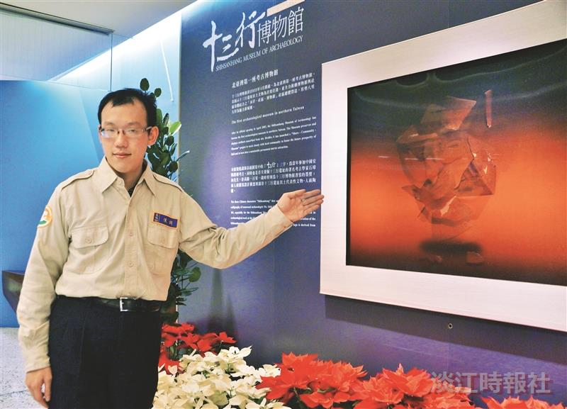
Alumni from the Graduate Institute of Japanese Language, Gang Chen, is working as a tour guide at the Shihanhang Museum of Archeology. (Photographed by Yi-feng Lu)

