Tamkang Times No.951
Guests from 23 Countries Come to TKU for Icedu Tech, ITS & STE Conference

From December 10th to the 12th, educators from 23 countries gathered together at TKU for the 2014 ICedu Tech, ITS & STE Conference. The conference included countries from Europe, the Americas, Africa, Australia and Asia. In total there were 65 honored guests that joined together for this great academic exchange hosted by Dean of the College of Education, Dian-fu Chang (second on the right) and Professor of the University of Aberta, Pedro Isaias (second on the left). IADIS gave special thanks to TKU for their assistance in the event.

Over the course of three days there were three presentations focusing on educational technology, online social media and continuing education. During the afternoon there was a tour of the university, showcasing its beautiful scenery and unique artifacts.
2014/12/25

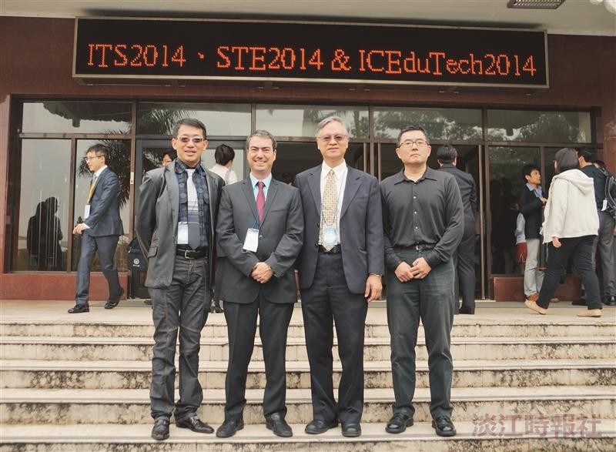
Director of National Normal University’s Educational Technology Center, Chun-yen Chang (first on the left), Pedro Isaias (second on the ?
left), and Director of the Department of Education, David Tawei Ku and Hsi-deh Wu take a photo together. (Article written b Ya-han Cao, Photographed by Yi-feng Lu)

