Tamkang Times No.948
Counseling Section Receives Intern Certification for Psychology

【Reported by Yi-ru Chen, Tamkang Times】The Counseling Section was honored with the 2014 official Intern Certification for counseling psychology by the Taiwanese Counseling Association on November 8th and received praise from National Taiwan Normal University. Director of the Counseling Section, Yen-wei Hu, stated, “It’s wonderful to be able to receive this qualification for psychology that verifies our professionalism. I want to give thanks to President Flora Chia-I Chang, officials and co-workers for all of your help and support.”

This certification acknowledges the basic fundamentals for training an intern including professional training, facilities, and all necessary requirements. Tamkang University had 10 individuals that performed exceptionally well, leading to this honorable recognition. Yen-wei Hu, described, “Every year we train 5 to 8 interns in areas such as personal counseling, psychological tests and assessments, mental health education advertising and crisis evaluation. All of the individuals who successfully pass these tests are given official certifications.

The Taiwanese Counseling Association’s secretary, Yi-xiang Hou, expressed, “The assessors found that the intern training provided by TKU is completely qualified with great supportive facilities, supervision and professional knowledge. Also the unique method of administration training allows students to prepare needed services in the field of psychology.”
2014/12/02

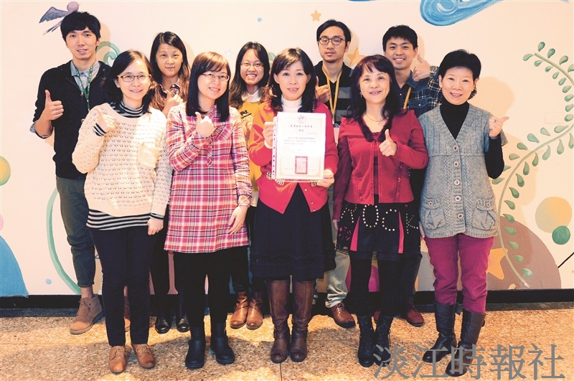
The Taiwanese Counseling Association Awarded the Counseling Section with the 2014 Intern Certification. Five Interns stood out in particular. (Photographed by Guo-zhen Wu)

