Tamkang Times No.947
International Boy Scout Exchange in Japan

【Reported by Qi-zhuo, Tamkang Times】Happy 90th Anniversary to Meiji University’s Boy Scout Troop! Director of Tamkang University’s Boy Scout Troup, Wen-Chih Huang, lead a group of three students to Japan for a visit with the sister school from November 1st to the 4th. Director Huang stated, “This trip was a celebration that allowed our two universities to really strengthen our ties. When the earthquake of 2011 happened, we donated funds to help the school in a time of need. That incident lead to us becoming sister schools in 2013.” Third-year student of the Department of Water Resources and Environmental Engineering, Bo-lin Liu, stated, “It’s such an honor to participate in this event! This is a great time to test our our language skills for a very meaningful and excited time.” (Article from http://tkutimes.tku.edu.tw/)
2014/11/25

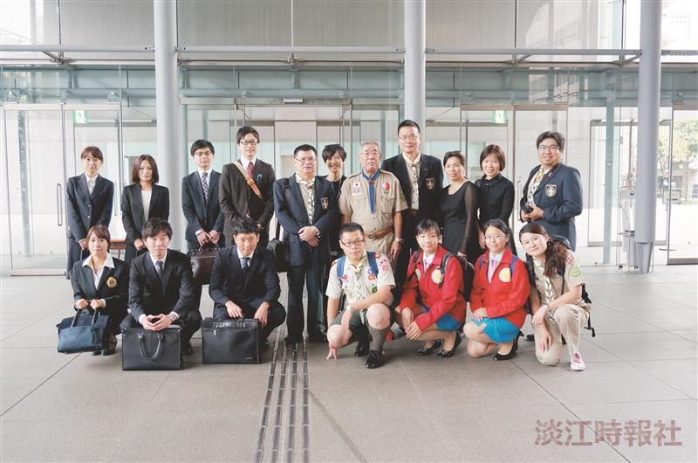
Director of the Boy Scout Troop, Wen-Chih Huang (back row fourth on the right) lead a team of three student: third year student of the Department of Water Resources and Environmental Engineering, Bo-lin Liu, second-year student of the Department of International Business, Wei-rong Chen (front row fourth on the right), alumni from the Department of Accounting, Zi-ling Liu (front row first on the right). (Picture provided by Wen-chih Huang)

