Tamkang Times No.947
Homecoming Banquet Takes Place for Anniversary Celebration

【Reported by Bo-jun Zhuang, Tamkang Times】Many exciting activities have taken place for Tamkang University’s 64th anniversary celebration including the beginning construction of the Chien Shou International Conference Center(CSIC) and the annual Homecoming Day celebration. In attendance for the homecoming banquet was President Flora Chia-I Chang, the three university vice presidents and contributors to the CSIC. The Golden Eagle Award was handed out and the Student Activity Center was filled with non-stop laughter.

President Chang expressed, “The 24,000 alumni have performed outstandingly over the years in every career field. Many academic industry projects have been established, which will create an abundance of opportunities for students in the future. The professors will also have more chances to come in contact with the industrial world, strengthening our educational system and overall competitive ability.”

During the ceremony, Executive Director of the Office of Alumni Services and Resources Development, Chun-young Perng announced, “Just now, Head of the Alumni of the Department of Chemistry Association, Jian-xiang Lin, donated 5,000,000 NT to the Chien Shou International Conference Hall!” The statement was followed by a thunderous applause of gratitude. Afterwards a total of 27 different performances took place, including the international students Lion Dance. The performances created a magical atmosphere of song, laughter and tears of joy. Director of the Department of Information and Library Science, Mei-yu Wang, stated, “So many of our alumni have had such fantastic success in the world, it’s touching to know that we are all part of the same family.” (Photographed by Guo-zhen Wu, Yi-feng Lu)
2014/11/25

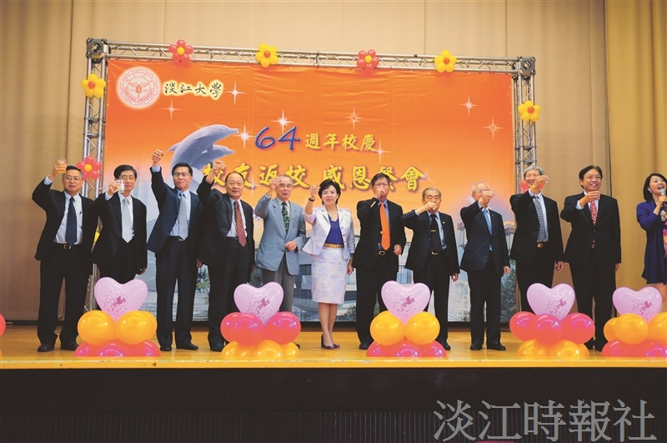
(Photographed by Guo-zhen Wu, Yi-feng Lu)

