Tamkang Times No.947
Nobel Prize Winner Rudolph Marcus Gives Lecture at TKU

【Reported by Yi-feng Lu, Tamkang Times】Photosynthesis and solar power are modern technologies that are continually being developed in the field of photochemistry. They revolve around utilizing the sun’s energy and transforming it into usable energy. Many of the roots of these developments lie in the, “Marcus Theory,” developed by Nobel Prize winner, Rudolph Arthus Marcus, who did extensive research in the 1950’s and 60s. On November 11th Tamkang University held the 19th International Workshop on Quantum Systems in Chemistry, Physics and Biology in the Chueh-sheng International Conference Hall. Professor Marcus was invited to give a lecture along with another Nobel Prize winner, Yuan Tseh Lee.

Dean of the College of Science, Bo-cheng Wang, expressed, “Rudolph Arthus Marcus was born in Montreal, Canada in 1923. He studied at McGill University, North Carolina University and then he became a professor at California Institute of Technology. Professor Marcus is a scientist whose theories had a dramatic impact in the world of science. His theory for electron transfer continues to lead to new findings and developments.”
2014/11/25

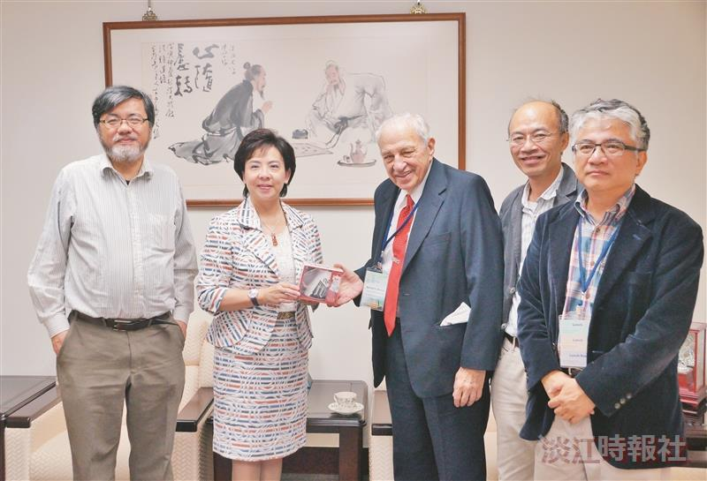
1992 Nobel Prize of Chemistry Award Winner, Rudolph Arthur Marcus (center) was invited to the Physics and Chemistry World QSCP-XIX Conference. President Flora Chia-I Chang (second on the left) greeted him. (Photographed by Yi-feng Lu)

