Tamkang Times No.944
Li-chou Gao Scholarship Awarded

【Reported by Jin-yu Cai, Tamkang Times】The official ceremony, awarding the Li-chou Gao scholarship took place on October 24th. This scholarship was initiated in 2003 and has helped 263 students, awarding a total of 13,150,000 NT. It was founded by alumni of the Department of Civil Engineering, Xin-ping Gao, who passed away last August. Tamkang University has decided to continue awarding the scholarship for the next 50 years in honor of his memory.

President Chia-I Chang, Executive Director of the Office of Alumni Services and Resources Development, Chun-young Perng and former Dean of the College of Science, Hsin-fu Tsai, spoke on behalf of Xin-ping Gao for his amazing contribution to the university. Xin-ping Gao founded the scholarship under his mother’s name to bring her honor for every person he could assist. His contribution serves as an example of dedication, love and responsibility.
2014/11/04

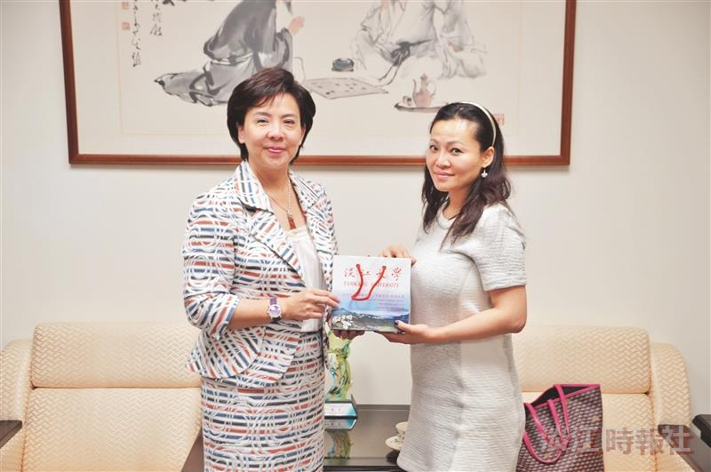
The Li-chou Gao Scholarship ceremony took place on October 24th, remembering Xin-ping Gao’s contribution. (Photographed by Yi-feng Lu)

