Tamkang Times No.943
One Student Association Candidate Disqualified for Running For Office

【Reported by Yi-feng Lu, Tamkang Times】A controversial issue ensued for the 20th annual Student Association Election. The three candidates running for student office, were asked to legally register on October 14th between the time of 12:00 and 12:30. One candidate and four-year student of the Department of Mass Communication, Bo-yi Cai, was tardy by ten minutes, and forfeit his running position. The student was understandably upset and contacted off-campus media to protest against the rule.

On October 15th the Student Voting Committee described the situation on their blog stating, “Bo-yi Cai was unable to register as a candidate in the required time slot and is disqualified from the running.” Dean of Student Affairs, Chih-en Ko, stated, “The Office of Student Affairs recognizes the Student Association as an autonomous organization and must respect the decisions made by the Student Association leaders. I hope that all of the students can respect the laws that have been established.” Chih-en Ko also explained that if Bo-yi Cai had entered the registration office at 12:30, there was still enough time to register. He stated, “The system is actually quite flexible, but regulations must be respected.”
2014/10/29

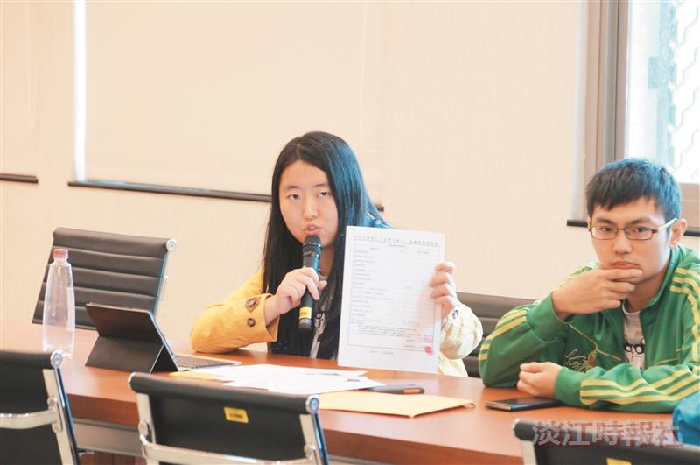
Student Association’s Candidate, Bo-yi Cai.

