Tamkang Times No.943
Student Association Meeting Takes on Recent Issues

【Reported by Jin-yu Cai, Tamkang Times】The 2014 Yearly Student Association Meeting took place on October 17th inside the Chueh-sheng International Conference Hall. Lanyang Campus also attended via video conference. The meeting was hosted by Dean of Student Affairs, Chih-en Ko, who invited Vice President of Administration, Yi-jen Hu.

Yi-jen Hu expressed that it’s important for students to have a fair platform from which they can discuss issues and opinions respectfully. Chih-en Ko described the recent events taking place on campus and stated that he had hopes of students actively voting in the upcoming elections. He also pointed out issues related to the environmental protections group, confirming that TKU has not used any contaminated or unsafe cooking oil, which has been the latest controversy on the news in Taiwan.

During the meeting they also went over the new modifications of the Student Absence Policy and Student Organization Autonomy. The students also brought forth questions of safety and prevention of danger, due to the recent attacks continually taking place in Taiwan. Director of the Office of Military Education and Training, Kuo-liang Chen, stated, “In the event of an attack the situation will be immediately monitored and analyzed by the Office of Military Education and Training.”
2014/10/29

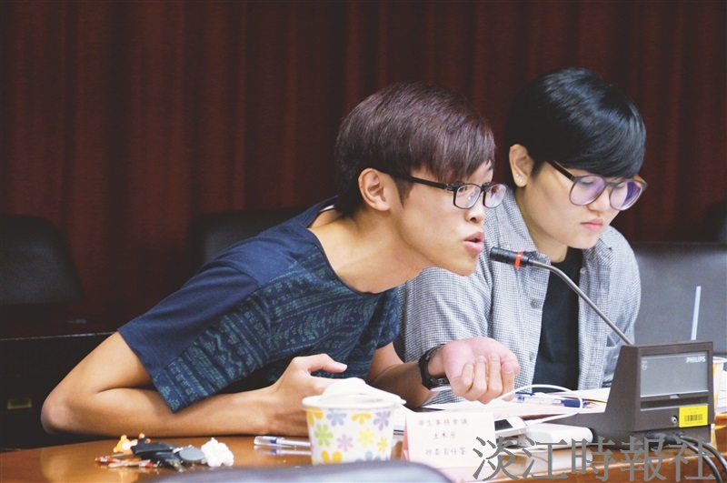
Student Representative and four year student of the Department of Civil Engineering, Ren-quan Xu makes a statement. (Photographed by Yi-feng Lu)

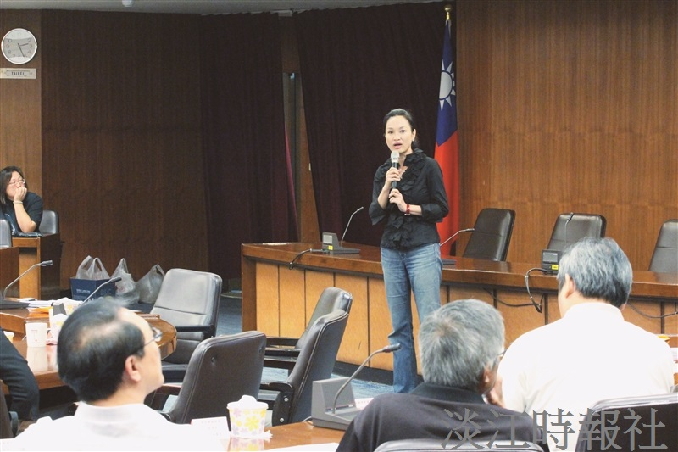
The first semester Student Association meeting takes place, hosted by Dean of Student Affairs, Chih-en Ko. (Photographed by Zhi-yue Jiang)

