Tamkang Times No.941
The College of Science and Better Chemistry Better Life Begin their Academic Cooperation

【Reported by Jin-yu Cai, Tamkang Times】The Department of Chemistry has officially begun their cooperation with Better Chemistry Better Life in their creation of an academic industry program. On September 30th President Flora Chia-I Chang met with the President of Better Chemistry Better Life, Ding-chuan Chen, to give a speech officially initializing the academic industry program. Also in attendance was Vice President of Academic Affairs, Huan-chao Keh, Vice President of Administration, Yi-jen Hu, Dean of the College of Science, Bo-cheng Wang, Dean of Research and Development, Der-wen Chang, and Director of the Chemistry Department, Jyh-shing Lin.

President Chang expressed, “Our new aim has been to establish these academic industry programs that give students a clear understanding of their career path and invaluable work experience. I’m truly grateful for the cooperation of Better Chemistry Better Life. This agreement will prove beneficial to both sides.” Ding-chuan Chen stated, “The research and study of solar energy will be something that I will keep a close eye on even after I am retired. New medicines can be made through contributions into the field of chemistry and it is a priority that Better Chemistry Better Life remain focused on ways to better the quality of life for the human race.”
2014/10/14

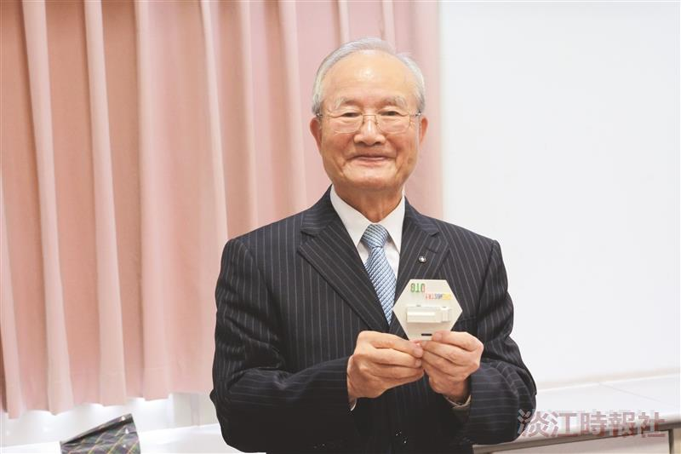
Dean of the College of Science, Bo-cheng Wang donates 3D technology to Ding-chuan Cheng. (Photographed by Guo-en Huang)

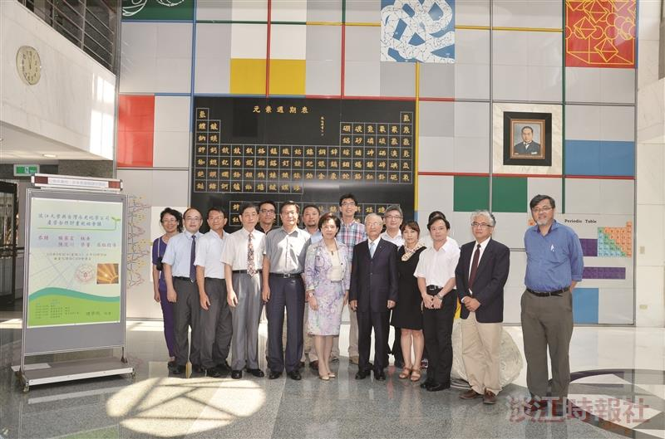
On September 30th President Chia-I Chang (middle) and President of Better Chemistry Better Life, Ding-chuan Chen (fifth on the right), came together for the new academic industry program. (Picture provided by Ji-fu Chen)

