Tamkang Times No.939
The Student Association Attends Election Meeting

【Reported by Yi-feng Lu, Tamkang Times】On September 17th students cast their votes for the 20th annual Student Association Elections. Due to certain controversial issues regarding legality of the vote, the Office of Student Affairs took the opportunity at this event to hold a meeting, clarifying legal issues in B302A. The event was hosted by Dean of the Office of Academic Affairs, Chih-en Ko, member of the Tamkang University Regulations Committee and Director of the Graduate Institute of European Studies, Li-chuan Chen, and Director of the Extracurricular Activities Guidance Section, Su-kuan Chiang.

Also in attendance were the two candidates for the Student Association’s vice president, student representatives and former Student Association Representatives. Out of respect for the students’ self governing system, Chih-en Ko, did not influence any of the decisions made by the student council. However, because of the recent controversies, Chh-en Ko served as a guide for university laws and regulations. The final decision was made in accordance of Article 5 of the Student Association Voting Act, stating that a revote must be cast and collected before October 30th. More information can be found at (http://tkutimes.tku.edu.tw/dtl.aspx?no=30310)
2014/10/01

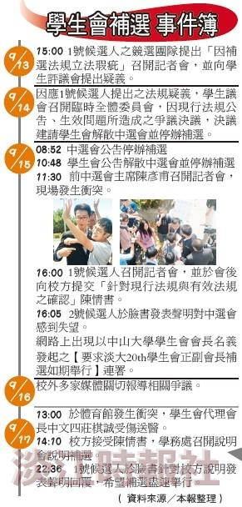
More information can be found at (http://tkutimes.tku.edu.tw/dtl.aspx?no=30310)

