Tamkang Times No.934
The 14th Annual Foreign Language Academic Conference has Over 200 Participants

【Reported by Bo-jun Zhuang, Ya-xuan Ji, Tamkang Times】For the promotion of foreign languages and concepts between the Cross-Straits, the College of Foreign Language held the “2014 14th Annual Foreign Language Academic Conference in the Chueh-sheng International Conference Hall on May 29th and 30th. Dean of the College of Foreign Language, Hsi-deh Wu, hosted as 6 representatives from the Foreign Language Department of Beijing University attended a conference with over 200 participants.

President Flora Chia-I Chang expressed, “Currently Tamkang University has 37 different academic exchanges with universities in Mainland China. The purpose of this conference is to serve as an encouragement to allow students to participate in more overseas exchanges to China in the future.” The conference covered three areas including the Cultural Groups, Language Academic Group and Increase of Language Needs in the Professional World. The conference mentioned issues of culture, academics, language study, translation, online studies and the cultivation of professional language skills for increased competitive capability.

Hsi-deh Wu expressed, “The College of Foreign Language has been holding this conference for many years and it has increasingly created an understanding of the Cross-Strait relationship and how to further develop it.”
2014/06/09

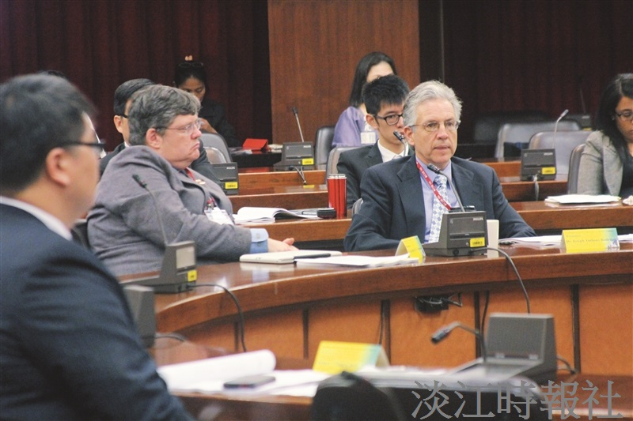
The Graduate Institute of America invited four well known educators from America, India and the Philippines on May 26th. (Picture taken by Zhong-yi Wu)

