Tamkang Times No.934
Cvilux and TKU Work Together to Market Products

【Reported by Wan-rou Zhang, Tamkang Times】On May 29th the Office of Research and Development and Cvilux Co. promoted the “Academic-industry Product Sales Conference.” Vice President of Administration, Po-yuan Kao, stated, “I’m very pleased to have this cooperation with Cvilux and grateful to the efforts of the Office of Research and Development that have lead to today’s successful event. I believe with the enthusiasm of the teachers and students we will be able to develop professional skills that will lead to the creation of great products. I look forward to what the future of this cooperation will bring.” Dean of the Office of Research and Development, Shung-wen Kang, expressed that he feels this cooperation with Cvilux marks a great accomplishment. He also expressed his thanks to the Department of Mass Communication and the Department of Information and Communication for the support.

The President of the board of Cvilux, Chaoqun Yang, stated, “Professor of the Department of Mass Communication, Jenn-jia Huang, and Professor of the Department of Information and Communication, Chien-chou Shih, were responsible for assisting in the design, product promotion, publicity and media advertising. I hope we have the chance to work together in the future to continue to make really competitive products.”
2014/06/09

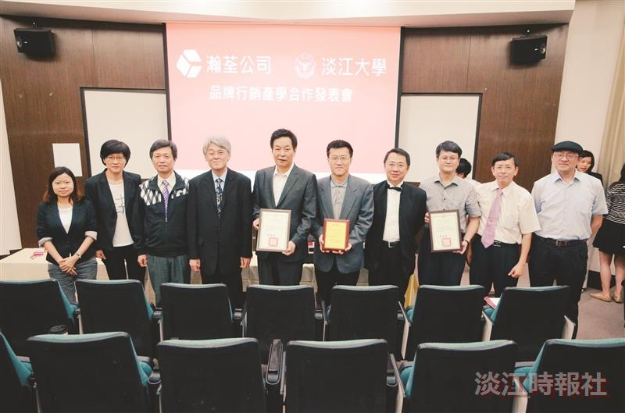
Tamkang University and Cvilux promoted the Academic-industry Product Sales Conference last Thursday. Afterwards Vice President of Administration, Po-yuan Kao (fourth on the left), Dean of the College of Liberal Arts, Sinn-cheng Lin (third on the left), Dean of the Office of Research and Development, Shung-wen Kang (fifth on the right, Dean of the Department of the Mass Communication, Huei-chun Chi (second on the left), Assistant Professor Jian-zhou Shi (first on the left) and President of the Board of Cvilux, Chaoqun Yang (fifth on the left) take a group photo. (Photo taken by Guang-qun Luo)

