Tamkang Times No.929
Ming-je Tang Gives Lecture on the Challenges of University Management

【Reported by Wen-yuan Zheng, Tamkang Times】The Office of Human Resources held the Administration Personnel Training Program on April 25th. They invited Vice President from National Taiwan University, Ming-je Tang, to give a lecture on “The Challenge of University Management.” He began by sharing his experience, research and explorations of the university management system in America and contrasted it to the modern governing system for higher education in Taiwan.

Ming-je Tang stated, “The university uses knowledge as a platform for interaction, research and passing information. The university needs to use diversified methods to encourage newly hired professors to do research. Research isn’t done for the end result, but for the process of development. It allows continual opportunity to reflect on the information and methods of relaying the academic data.” In addition to this Ming-je Tang pointed out that universities are currently faced with a dilemma. He stated, “As university professors get older so does the structure of the educational development system. It can make it difficult to adjust to new methods of learning such as online courses. If the older faculty is unwilling to adapt to the new systems of education, the university will be at a loss.” Vice President of Academic Affairs, Gwo-hsing Yu, stated, “There are indeed many challenges we are faced with for university management. Thank you so much Ming-je Tang for your truly enlightening lecture.”
2014/05/02

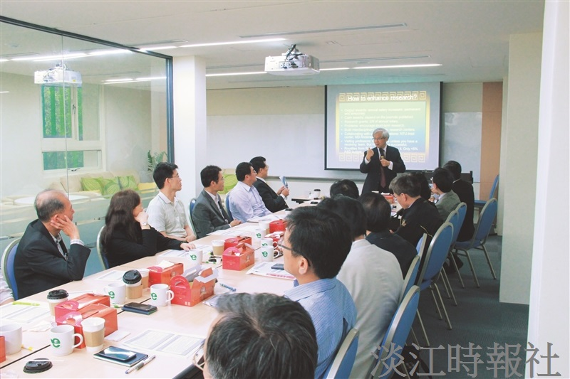
Vice President from National Taiwan University, Ming-je Tang, came to TKU to give lecture on April 25th. (Picture taken by Guo-en Huang)

