Tamkang Times No.926
The International Students Take a Trip to Nantou

【Reported by Tian-ran Xia, Tamkang Times】The International and Mainland Guidance Section held the yearly Spring Culture Tour on March 22nd and 23rd. Accompanying the 91 international students was Vice President of International Affairs, Wan-chin Tai and Dean of International Affairs, Pei-wha Chilee. Wan-chin Tai happily expressed, “It’s always our desire to really let the international students have a chance to enjoy the mountains, bodies of water and beautiful scenery of Taiwan. We want it to be a memorable experience with lots of different flavors that they will be able to take with them in their hearts when they return to home.”

The total trip lasted for 2 days and one night. The weather was fresh and crisp as they explored the regions of Nantou, Xitou Nature Education Area, Monster Village and the plains of Zhanghua. When they arrived in Xitou there was a light sprinkle, but no one wanted to cut the trip short because they were having such a special time. Smiles dawned on every face as they were able to come in contact with an array of plantlife. Second-year student from the Department of International Business Management, Xia-tian Er, stated, “We all began hiking at 6 in the morning and the air was truly soothing and invigorating.”

On the following day they hiked up Bamboo Mountain and tasted the local delicacy known as “Moiji”. They also learned a vast amount about the culture and history of Bamboo Mountain while observing the many authentic bamboo crafts. Third-year student from Malaysia, Reng-yun Zhang, stated, “I’m so happy I finally got the chance to taste the delicious Moiji.” Second-year student from Canton, Wei-ya Zhu, stated, “At night we shared rooms and had a chance to interact with the other exchange students. I even picked up a bit of Korean.”
2014/04/11

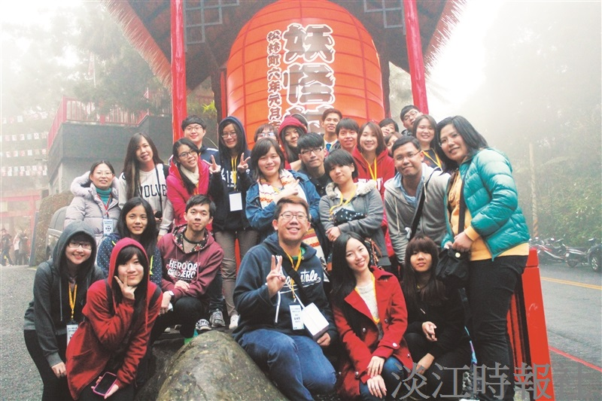
The international students take a group picture at Monster Village in Nantou. (Picture provided by the Office of International Affairs)

