Tamkang Times No.926
The Department of Aerospace Engineering Designs UAV That Receives Three Awards

【Reported by Jia-wen Lin, Tamkang Times】After 2012 the Department of Aerospace Engineering has been researching Unmanned Aerial Vehicles (UAV). On March 22nd and 23rd they participated in the 2014 Taiwanese Unmanned Aerial Vehicle Creative Design Competition and received excellent recognition in three different categories. The UAV known as Orion received first place for Aerial Engine Design, first place in Aerodynamic Force, and third place in Technical Manufacturing. Professor of the Department of Aerospace Engineering, Der-ming Ma, stated, “Unlike the single winged plane design of last year, this time we made a tandem aircraft.”

Professor Der-ming Ma uses a very active approach when teaching the kids in order to encourage them to challenge their ideas. When the students finished the design for Orion, their teacher highly approved by saying, “These awards are well deserved!”

There were 33 members involved in the creation of Orion and it took a total time of 6 months to complete the task. Team supervisor of the UAV research room and third-year student of the Department of Aerospace Engineering, Kai-jun Wu, stated, “There haven’t been many tandem aircraft designs so it was very difficult to gather the needed data for the project.” Judging from the students achievements, it is apparent that their diligence with the support of their teacher goes a long way.
2014/04/11

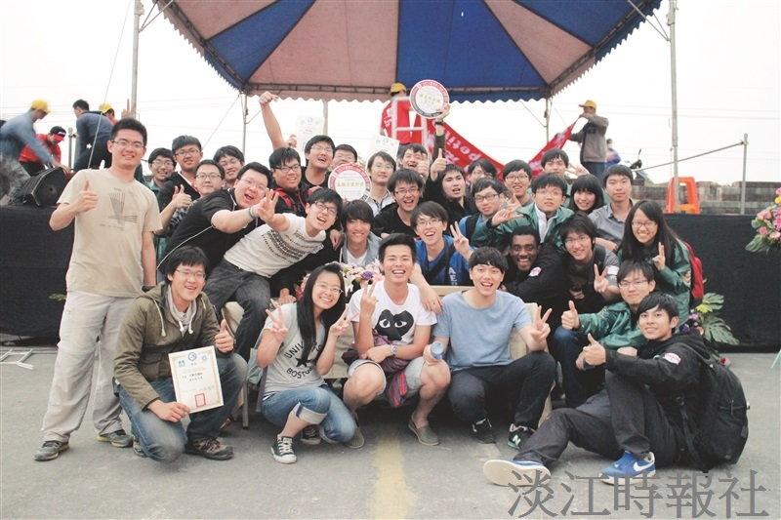
After the competition the entire team from the UAV research room took a group photo with their awards. (Picture provided by UAV Research Room)

