Tamkang Times No.922
An Academic Exchange Takes Place in Fuyuan Garden

Zhou-chen YI, from Zhejiang Industries came to the Fuyuan Garden to have an academic exchange with students and professors from all around. He stated that this discussion was very purposeful and he has already adjusted to the academic-industry lifestyle provided on campus. He said that when he participates in the Mainland Alumni Association, he hopes to be able to provide them with a more global perspective. (Article and Picture provided by Deng Xiang)
2014/03/07

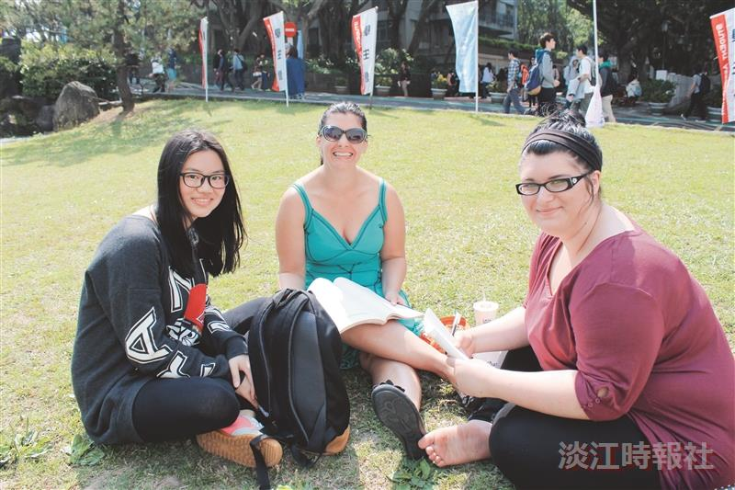
(Article and Picture provided by Deng Xiang)

