Tamkang Times No.922
Alumni Association of Northern California Holds Celebration For Year of the Horse

A member of the Alumni Association of Northern California and Golden Eagle Award Winner, Sandy Yeh, has been invited to participate in the “San Francisco Great Moon Calendar Parade” that will have over a hundred different alumni teams in attendance. President of the Alumni Association of Northern California, Jane Yip, expressed that being able to get invited to this event is considerably difficult. She stated, “Alumni feel that it is their responsibility to spread Chinese art and culture around the world. So for someone to be able to participate in such an event is truly a great honor.” (Article provided by Yu-yu Liu/ Picture provided by the Alumni Association of Northern California)
2014/03/07

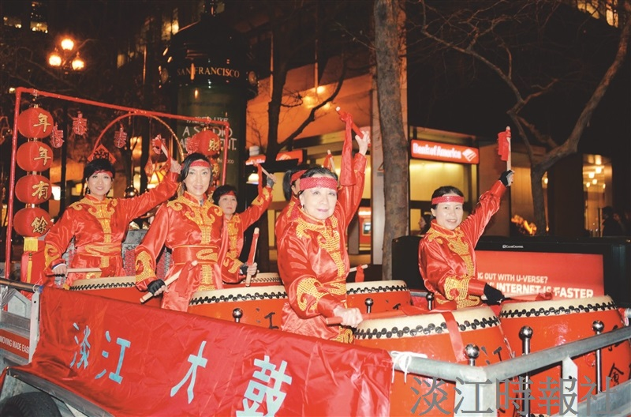
Alumni Association of Northern California Holds Celebration For Year of the Horse

