Tamkang Times No.920
Tamkang University’s Digital Book City

【Tamkang Times】Tamkang Univeristy’s Digital Book City is brand new and online. Now all of the information of campus can be accessed at your finger tips. The TKU Digital Book City contains pictures, Chinese characters, e-books, and articles that can all take the shape of your smart phone or personal computer. The entire faculty and student body now have ready access to this technology due to the generous donation of the “Multimedia Interactive Platform” made by Chairman of the Board of Trustees of Chidopi, Ying-chun Chuang. After it has been verified, the Digital Book City will be available for everyone to download.

The Secretary of the College of Liberal Arts, Yi-Ping Su, stated, “The Digital Book City will be available for the entire university. Professors will be able to have a platform for their academic achievements, students will have a place to display their creativity, every professor and teacher from every department will be able to promote ideas and products. Everyone is invited to take advantage of this useful tool.” In order to have a deeper understanding of this “Multimedia Interactive App” the College of Liberal Arts is offering a training program. For information about the program, contact the College of Liberal Arts at ext. 2300. The Digital Book City can be downloaded directly to iOS or Android.
2014/02/22

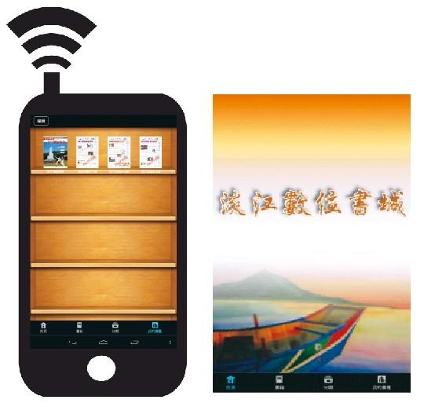
Tamkang University’s Digital Book City (Picture provided by Tamkang Times)

