Tamkang Times No.907
President of University Tunku Abdul Rahman Visits TKU

【Reported by Hong-jia Gu, Tamkang Times】On November 14th six visitors came to TKU from sister University Tunku Abdul Rahman including Chief of the board, Tun Tan Siew Sin, University President and Supervisor, Dr. Chuah Hean Teik, Vice President and Associate Professor Lee Sze Wei, Dean of the College of Science, Lim Tuck Meng, and Dean of the College of Engineering, Robert Gilmore. The guest were given a tour of the campus buildings and many facilities. Dr. Chuah Hean Teik stated, “This is my first time seeing such a lovely campus. I think the robotics center is incredibly interesting.

When the discussion took place, over 400 students and faculty attended, including President Flora Chia-I Chang, Vice President of International Affairs Wan-chin Tai and the dean of every department. The discussion between the two universities took place in the Chueh-sheng Memorial International Conference Hall and was mostly focused on exchange programs and policies. So far 20 students have participated in the Tamkang University and University Tunku Abdul Rahman exchange program. In the future they plan to sign an official agreement to stimulate further exchange opportunities. The University Tunku Abdul Rahman is a new graduate institute in Malaysia. It is also the first private institute in Malaysia to support a complete English educational curriculum.
2014/02/20

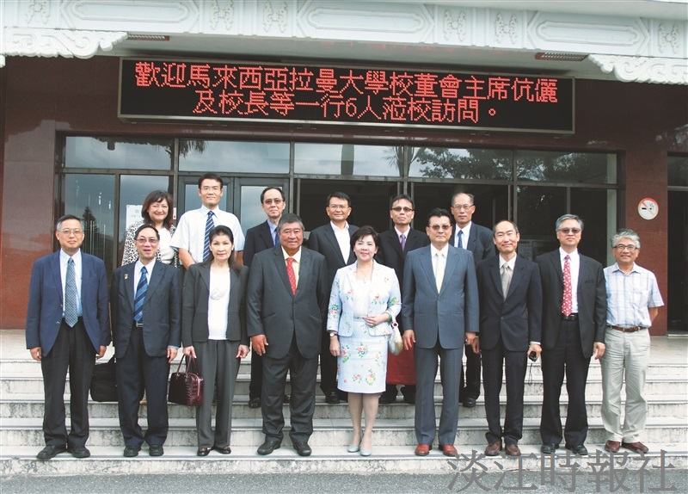
President Flora Chia-I Chang (Center) Vice President of International Affairs, Wan-chin Tai (Center Right) and the six guests from Malaysia. (Picture Provided by Yi-jie Lai)

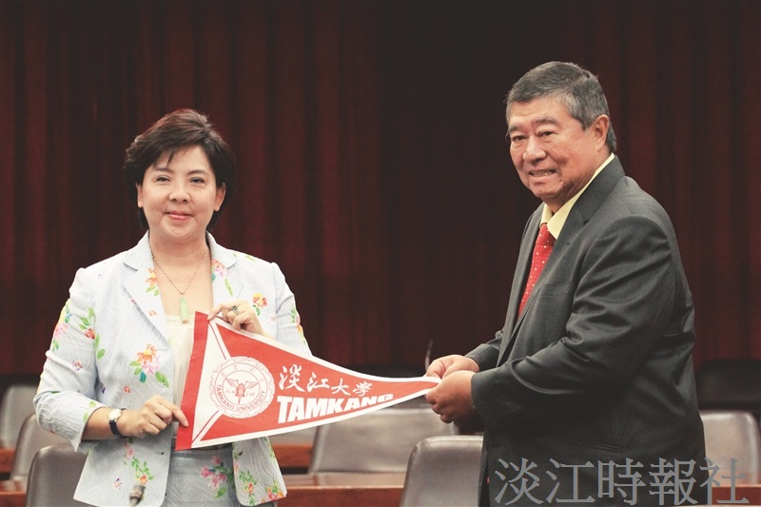
President Flora Chia-I Chang (Left) with Tun Tan Siew Sin (On the Right). (Picture provided by Yi-jie Lai)

