Tamkang Times No.908
Campus Environment Quality Improvement Begins with Business and Management Building

【Reported by Jing-Ya Su, Tamkang Times】Welcome to the new remodel of the Business and Management Building! On the 22nd the College of Business and Management held a tea party for the “New Remodel of the Business and Management Building.” The Dean the College of Business and Management, Chien-liang Chiu, invited President Flora Chia-I Chang, Vice President of Academic Affairs, Gwo-Hsing Yu, Vice President of Administration Po-yuan Kao, and Vice President for the Office of International Affairs, Wan-chin Tai, to celebrate the Business and Management Building’s new make over.

Chien-liang Chiu stated, “This new remodeling represents the new attitude and cooperation of the College of Business and the College of Management. I expect that this new environment will have a significant effect on the students’ performance. I want to thank the university for making this possible and giving the students an even brighter academic future.”

President Chang stated, “We began the remodeling of the campus starting with the College of Business and Management because it is the department with the most students. In the future we will slowly started upgrading all of the buildings on campus. From the time of the union of the College of Business and the College of Management our achievements as a university have improved dramatically. In the future we want to give all students a magnificent space for their studies just as this one. I know that the students’ performances will become even more exceptional as our campus improves. ”

For details on the renovations on campus see link. (http://www.general.tku.edu.tw/enable/jindex.php）
2014/01/22

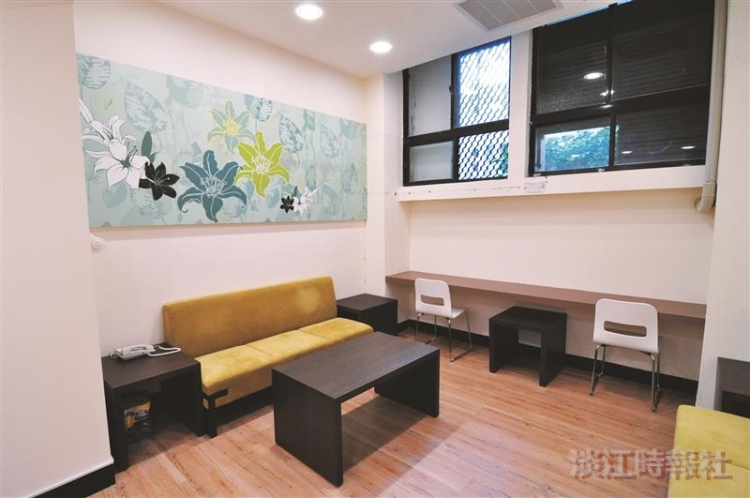
The Business and Management Building’s faculty lounge room.(Picture provided by the Office of General Affairs)

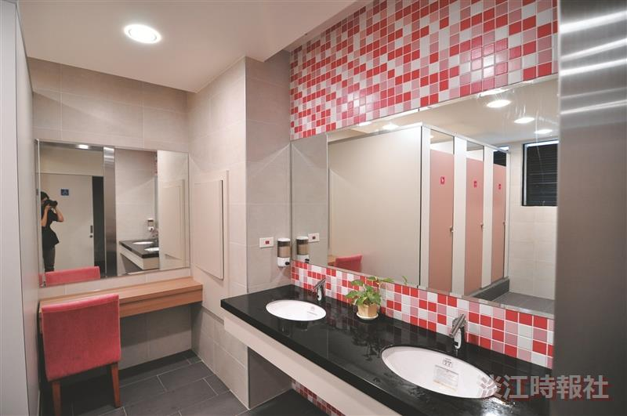
The Business and Management Building’s faculty female restroom. (Picture provided by the Office of General Affairs)

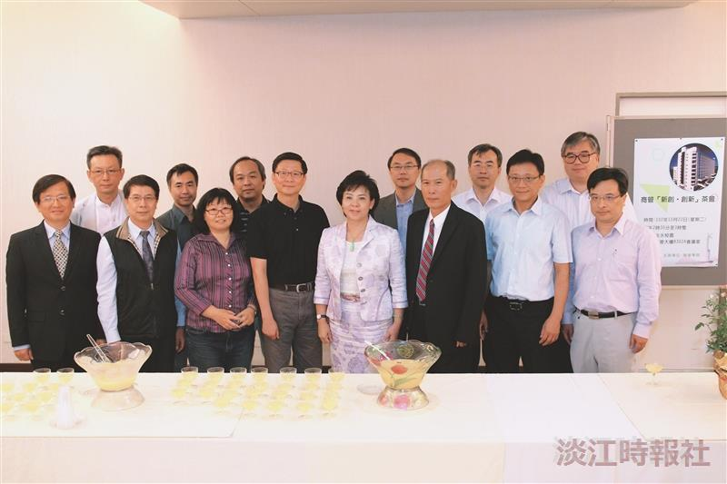
President Flora Chia-I Chang (First row, fourth on the left) attends Business and Management New Remodel Tea Party with the Dean of Business and Management, Chien-liang Chiu. (Picture provided by Xiang Deng)

