Tamkang Times No.915
You-Yi Hou Leads A Discussion on Creating the Future of Education

【Reported by Qian-wen Fan, Tamkang Times】In the morning on December 11th, Tamkang University’s College of Education held a conference titled, “The Future of Education and Imagination- Construction of Danhai’s International City of Education” in the Chueh-sheng International Conference Hall. The forum was hosted by President Chia-I Chang who stated, “We have mentioned that the vision of this university is to combine a global educational system with the culture of Taiwan. In order for that to happen we must have an educational system that is internationally-oriented at it’s core structure, yet the system, plans and policies must not abandon the Taiwanese identity. It is my wish to implement this concept with the help of the Danhai government to develop the International City of Education.

Deputy Mayor of New Taipei City, You-yi Hou, expressed, “New Taipei City has always been in support of an international education. I hope that the College of Education will plan out a globalized educational system for the elementary students in Danhai including curriculum development, professional personnel, and overseas programs. By promoting a thorough international program, the youth of Danhai will naturally spread Taiwanese culture across the globe.

All of the members of the discussion forum were in agreement as they laid out the future plans and outlines of a brand new international city of education. Also in attendance was Supervisor of the New Town Construction Division, Chi-yuan Hung, Chief Secretary of New Taipei City Education, Tengjiao Lin, Chairperson of New Taipei City Elementary Education, Rong-hui Zhang, Chief Secretary of New Taipei City District, Ye-wei Cai, Tamkang University’s Dean of the Office of General Affairs, Shiaw-shyan Luo, Director of the Department of Architecture, Jui-mao Huang, President of Tamkang Times, Yu-pei Ma and Dean of the College of Education, Dian-fu Chang. Each member of the forum delighted in the discussion of the birth of a new future for Danhai.
2013/12/20

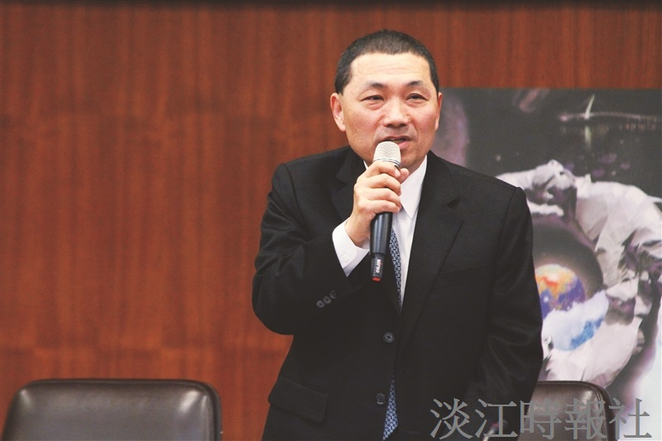
Picture for the Deputy Mayor of New Taipei City, You-yi Hou.（Photographed by Deng Xiang）

