Tamkang Times No.901
TKU i-Life New Feature

The TKU i-Life app integrates library information and the most recent news in the Tamkang Times, allowing users to more quickly view real-time campus information. The library information provides opening hours, overdue records, museum appointments, library records and new e-resources. The Tamkang Times has the latest news items, a lecture billboard, an events billboard, and other content.

Updates of the TKU i-Life app will be available after mid-August, and teachers and students are welcome to install it onto their hand-held devices. The app can be downloaded for free from Google Play and the app store after entering a keyword search. Hurry up and come check it out!
2013/09/02

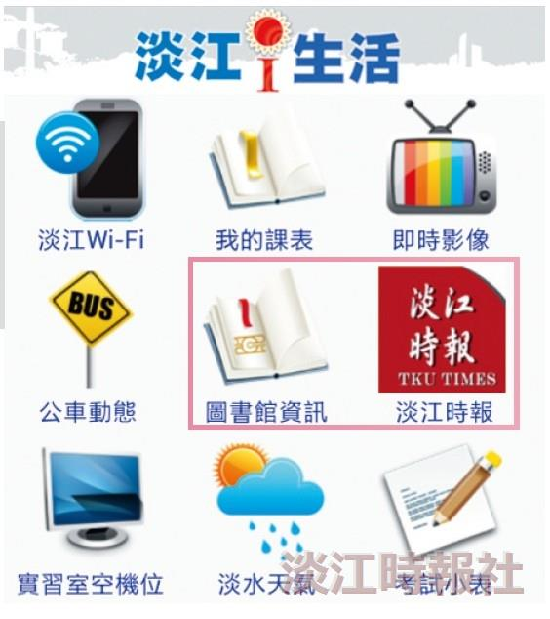
The TKU i-Life app has added library information and the Tamkang Times, allowing users to more quickly gain an understanding of campus information. (Picture source is a screenshot from a mobile device.)

