Tamkang Times No.901
Tamkang Wins National Environmental Education Award, Corporate Environmental Award

After TKU won the New Taipei City Environmental Education Award School Group Excellence Award issued for the first time by the Environmental Protection Administration under the Executive Yuan, General Affairs Director Lo Hsiao-hsien received the award on the behalf of the university on June 23rd. TKU participated in the awards selection of the 3rd year of the ROC Enterprise Environmental Protection Award on the 13th with 14 judges visiting the school. With the possibility of winning the Honorary Environmental Enterprise Award, participation this time is significant, for if selected, TKU would become the environmental protection benchmarking model for national higher education.
2013/09/02

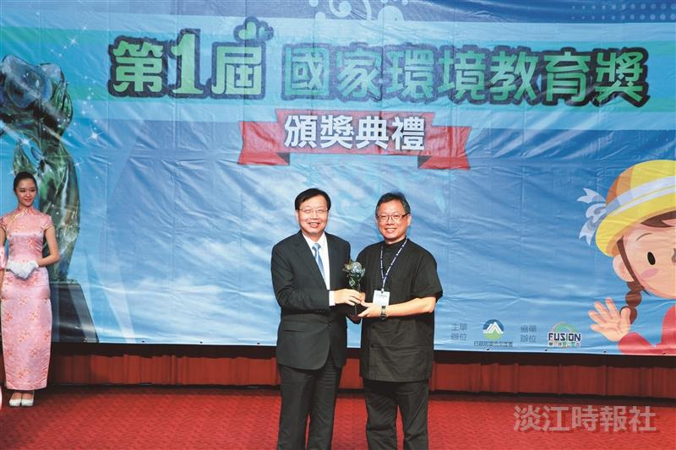
TKU wins 1st National Environmental Protection Education Award School Group Excellence Award issued by Executive Yuan Secretary-General Chen Wei-Jen (left) on June 23rd, with General Affairs Director Lo Hsiao-hsien (left) receiving the award on behalf of the school. (Picture provided by Executive Yuan EPA)

