Tamkang Times No.897
Voting for New Leaders of the TKU Student Association

The TKU Student Association recently held ballots to select a new president, vice president, and Association representatives. The result of these ballots was released on May 17. And on May 22, a ceremony was held to inaugurate the newly elected leaders.

The ceremony was attended by the Dean of the College of Liberal Arts, Dr. Chiu Jeong-Yeou, and the Section Chief of the Extracurricular Activities Section, Chiang Su-Kuan.

The new leaders came from various departments and graduate institutes, including the Department of Japanese (Chiu Yu-Zhen) and the College of International Studies.
2013/06/08

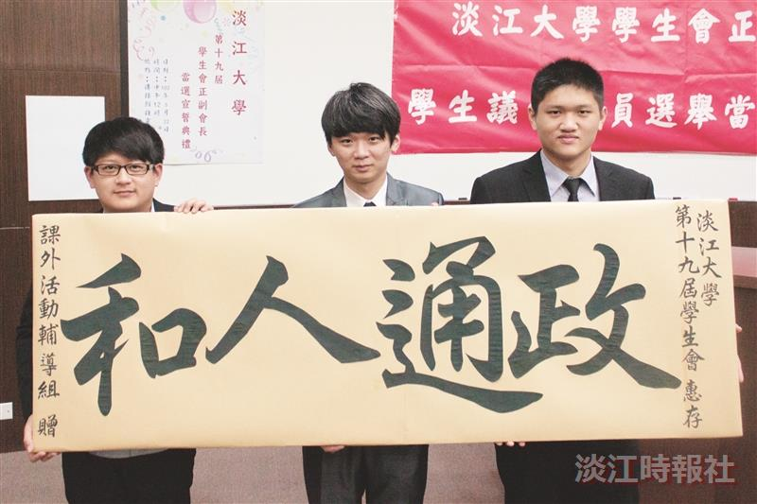
The new leaders of the TKU Student Association.

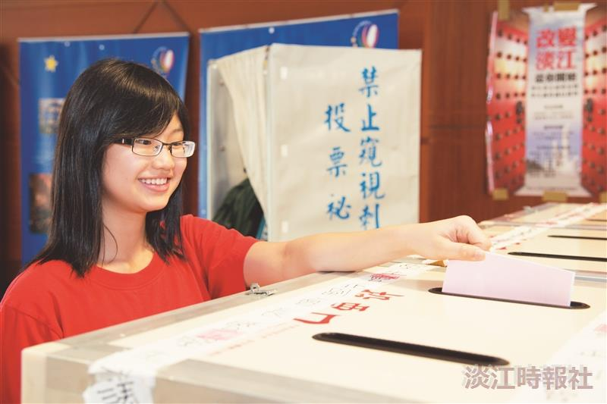
Students cast votes to elect new student leaders.

