Tamkang Times No.896
TKU Foreign Languages Week

Starting from May 13, the annual event known as “Foreign Languages Week” was held at Poster Street on the Tamsui Campus. The event comprises fun games, entertainment, and a raffle, and draws vast throngs of students as well as TKU senior staff, such as the President, Dr. Flora Chia-I Chang, who came to the opening ceremony and helped cut the ribbon to mark the event’s commencement. Other attending staff members included the Vice President for International Affairs, Dr. Wan-Chin Tai, the Dean of the College of Foreign Languages and Literatures, Dr. Wu Hsi-Deh, and the chairs of each of the College’s departments.
2013/05/28

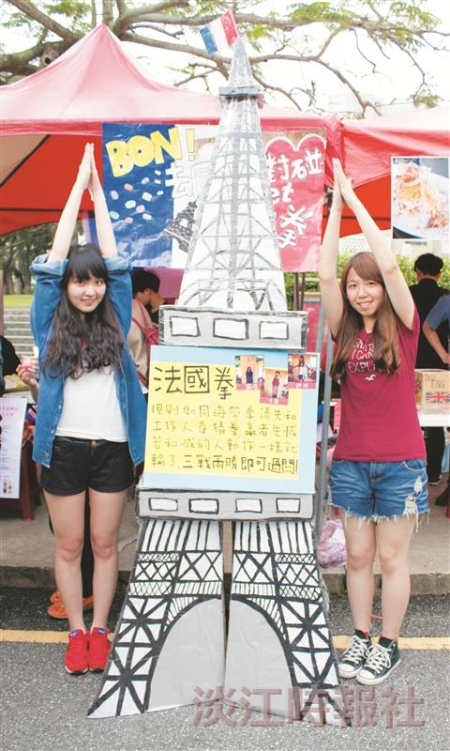
TKU Foreign Languages Week

