Tamkang Times No.884
A Teary Farewell for Tamkang Retirees

On 10th January, retiring TKU employees were honored at a ceremony held at the Chueh Sheng International Conference Hall, Tamsui Campus. The ceremony was attended by the President of TKU, Dr. Flora Chia-I Chang, and the former Minister of Education and current Chair Professor at TKU’s Graduate Institute of Educational Policy and Leadership, Dr. Wu Ching-ji. Close to 100 TKU students and teachers also came to bid farewell to the retiring members.

During the ceremony, President Chang handed out crystal plaques to those retiring. In her opening remarks, she noted that this is the first time for former Minister of Education Wu to attend the ceremony, and that it is an honor to have his presence at the event. She also thanked retiring TKU members for their years – and in some cases decades – of service and hard work.

Among those retiring was Associate Professor Yuh-Yeh Pan, who served in the Department of International Business for 42 years. Dr. Pan, who choked back tears several times during her speech, noted that she had been at Tamkang long enough to see six separate university presidents come and go. “During my journey, I’ve built a deep emotional connection with Tamkang.”
2013/02/27

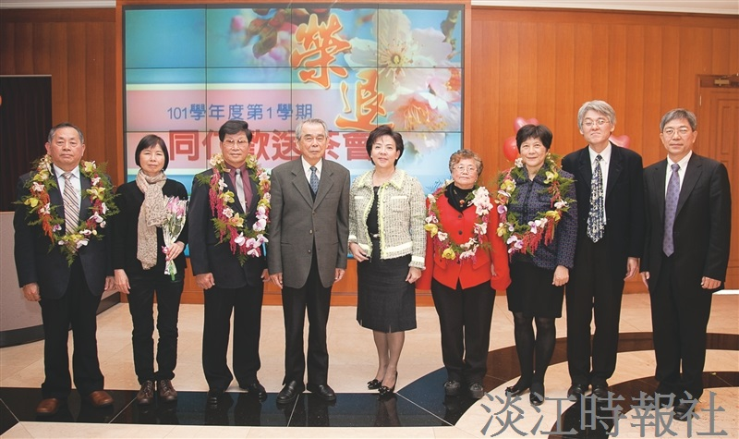
President Chang (5th from left) in a group picture with retiring TKU employees.

