Tamkang Times No.880
An Early Xmas at TKU

On December 13, 2012, the TKU Center of Continuing Education (TKU Taipei Campus) held its annual Christmas Campus Fair. To celebrate a multicultural Christmas, the 2nd floor of the Taipei Campus was transformed into a bustling fair with stall after stall of delicious foreign food. The stalls offered food from Vietnam, Korea, America, and Austria, among others. Li Hsueh-Li, an international student from Thailand, expressed that "it's so much fun studying Chinese with students of various ethnic backgrounds at Tamkang!"
2012/12/26

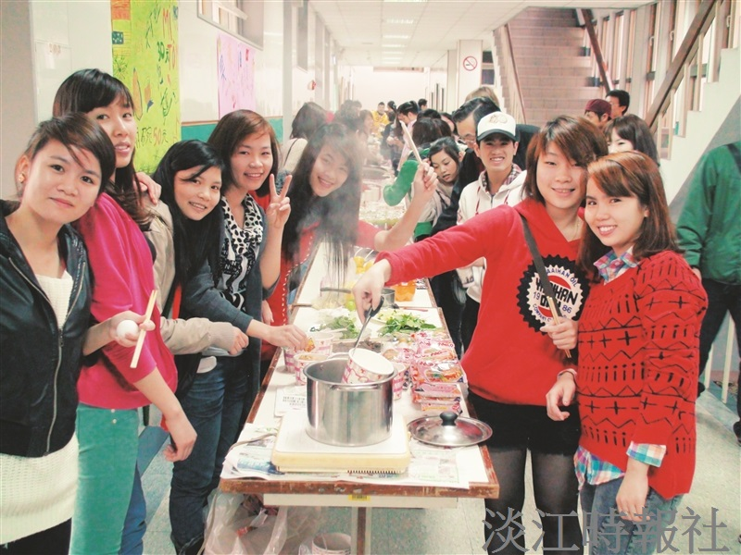
On December 13, 2012, the TKU Center of Continuing Education (TKU Taipei Campus) held its annual Christmas Campus Fair. To celebrate a multicultural Christmas, the 2nd floor of the Taipei Campus was transformed into a bustling fair with stall after stall of delicious foreign food. The stalls offered food from Vietnam, Korea, America, and Austria, among others. Li Hsueh-Li, an international student from Thailand, expressed that “it’s so much fun studying Chinese with students of various ethnic backgrounds at Tamkang!”

