Tamkang Times No.875
A New Li Chi Mao Gallery in Shandong

A new Li Chi Mao Art Gallery recently opened (October 12) in Gao Tang County of Shandong Province, Mainland China. Li Chi Mao is a long-serving resident artist at Tamkang University and is the former director of the TKU Carrie Chang Fine Arts Center.

Attendees at the opening ceremony of the new art gallery included the current director of the TKU Carrie Chang Fine Arts Center, Prof. Chang Ben-Hang, as well as numerous artists and government officials from both Taiwan and Mainland China.

The new gallery is a product of Li Chi Mao’s efforts over the last two decades to promote cross-strait artistic interaction and exchange.
2012/11/20

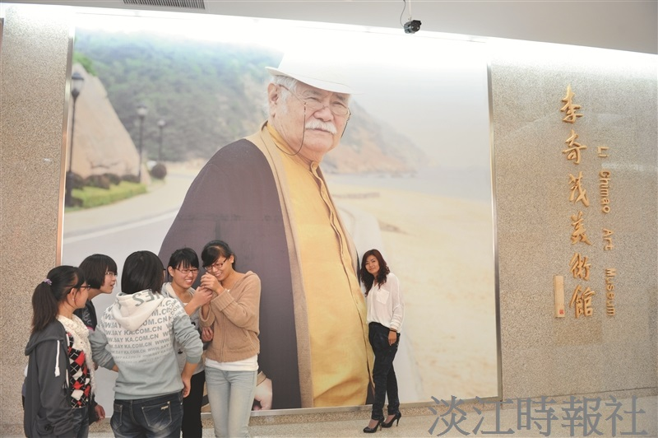
The new gallery is a product of Li Chi Mao’s efforts over the last two decades to promote cross-strait artistic interaction and exchange.

