Tamkang Times No.870
A Vow of Diligence

On the afternoon of October 3rd, a large group of freshmen gathered on the bridge-style walkway that leads into the College of Liberal Arts. They were wearing high school uniforms as part of a department-organized activity known as annual uniform day.

To coincide with Annual Uniform Day, the Department Association held a unique “vow of diligence” activity. As part of the activity, Department of Chinese Literature master’s student, Wu Wen-Chi, represented all students from the department by vowing to the Chairperson of the Department, Dr. Yin Shan-Pei, that “we will not cut class, plagiarize, and will serve as model students”.
2012/10/17

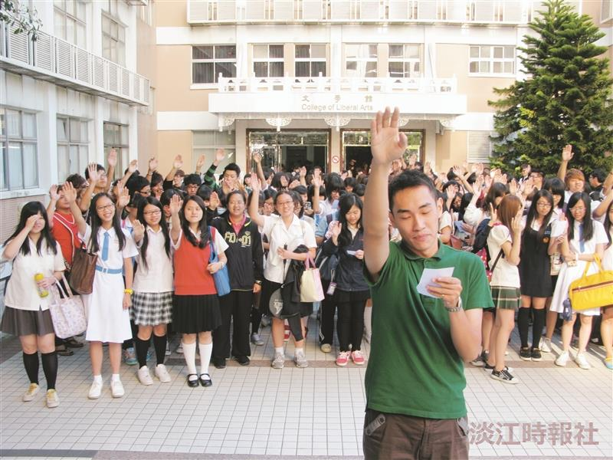
A Vow of Diligence

