Tamkang Times No.867
Making History in Arcade Basketball

TKU Third year Physics student, Zhou Yu-Ting, was recently crowned the world champion of arcade basketball. Out of over 300 contestants from countries around the world, Yu-Ting claimed top spot in the 7th China Cup Tournament, breaking his own world record (which he set in 2010) with a phenomenal total score of 2493. When asked of his thoughts on his triumphant performance, Yu-Ting said: “I’ve been working hard for this for the last four years. I believed that I could do it, and now I’m finally the world champion. In the future, I plan to keep training hard in order to keep the world champion trophy in Taiwan”.
2012/09/28

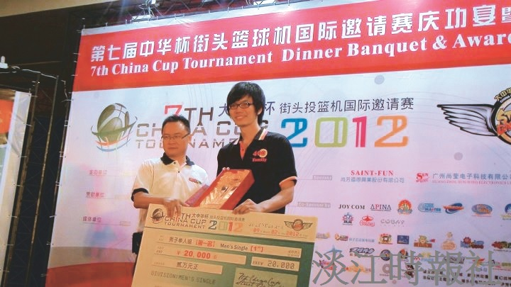
Third year Physics student honored at the 7th China Cup Tournament.

