Tamkang Times No.866
TKU’s Contribution to Science

Following the “Golden Snitch” documentary series, shown as part of the 2009 science-based program “Contemporary Craftsman, Luban”, Da Ai TV has recently broadcast a new science program known as “Imitating Nature”. The show takes a complicated topic – bionics – and makes it accessible and interesting to the general public. Bionics, which involves a mixture of physics, biology, and chemistry, is the study of how to replicate natural processes used by animals that fly or animals that glow.

In the second installment of the series, the “TKU Golden Snitch Team”, led by the Chair of the Department of Electro-Mechanical Engineering, Prof. Lung-Jieh Yang, introduces the audience to micro aerial vehicles with “flapping-wing” designs. They explain that given advancements in technology, the fourth generation of golden snitch micro aerial vehicles can now fly for over ten minutes at a time. In the future, they hope to mass produce these vehicles and sell them internationally.
2012/09/19

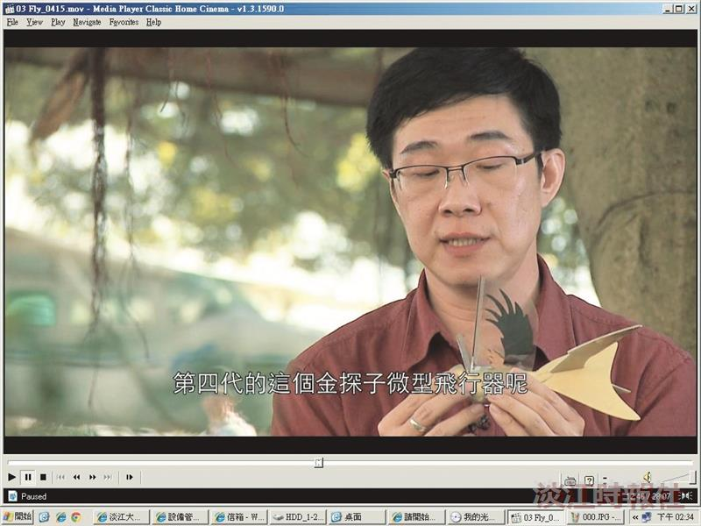
The Chair of the Department of Electro-Mechanical Engineering, Prof. Lung-Jieh Yang, describes the structure of the golden snitch on the program “Imitating Nature”.

