Tamkang Times No.830
Climbing the 'Slope of Overcoming Difficulty'

Each year, as the academic year commences, Tamkang holds a unique welcoming ritual for newly arrived freshmen. The ritual involves new students, teachers, and the president of TKU, as well as a steep slope with a peculiar name: the ‘Slope of Overcoming Difficulty’. Comprising of 132 steps, the slope was once the sole path leading to the Tamsui Campus. Now, students and staff scale the slope to truly live out the message behind the slope: that difficulties are temporary and can be overcome.

The scaling of the slope has become a Tamkang tradition that this year took place on the mornings of Sept 1 and 2. This year, 7000 new students were led up the steep hill by the three TKU vice presidents. Among the 7000 students was Wu Ji-xuan, a Department of Chinese freshman and practitioner of Tibetan Buddhism who stood out by virtue of her Buddhist robe. She said “Although walking the slope of overcoming difficulty is very tiring, it is a meaningful ritual aimed at passing along the Tamkang tradition to upcoming generations”.

After the students made it to the top, they were taken to a ‘Beginning of Semester’ Ceremony, which kicked off with an energetic Chinese lion dance, and performances by TKU Tae Kwon Do, dance, and cheerleader societies. During the ceremony, the TKU Vice President for Academic Affairs, Dr. Gwo-hsin Yu, delivered a speech in which he explained that “one’s attitude decides their future success”. He encouraged the students to use their time at Tamkang to develop their own unique qualities, and quoted a phrase from the Founder of Apple Inc., Steve Jobs: “Stay hungry, stay foolish”, appealing for students to maintain their hunger for knowledge, yet at the same time to remain humble.
2011/09/15

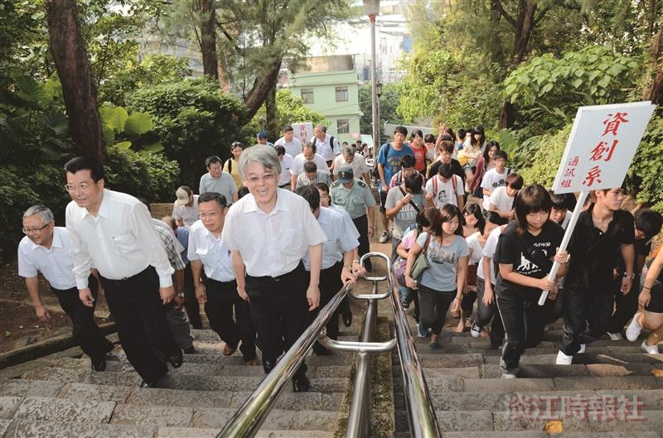
TKU faculty and staff lead 7,000 freshmen up the ‘Slope of Overcoming Difficulty’.

