Tamkang Times No.828
TKU Dance Clubs Dance for Their Lives

Fighting a battle with weapons is nothing out of the ordinary. But try fighting a battle with dance moves alone. On the 5th June, the TKU Dance Club held its end-of-semester performance, which incorporated skillful dance steps into the background theme of ‘war’. Guest appearances were made by the TKU Magic Club and the TKU Extreme Dance Student Association. Dance styles displayed on the night included jazz, hip hop, reggae, as well as martial arts style performances.

Second year Department of Chinese student, Chu Jia-ying, said that “after watching the performances, I really want to join the dance club and learn hip hop next semester!”
2011/06/20

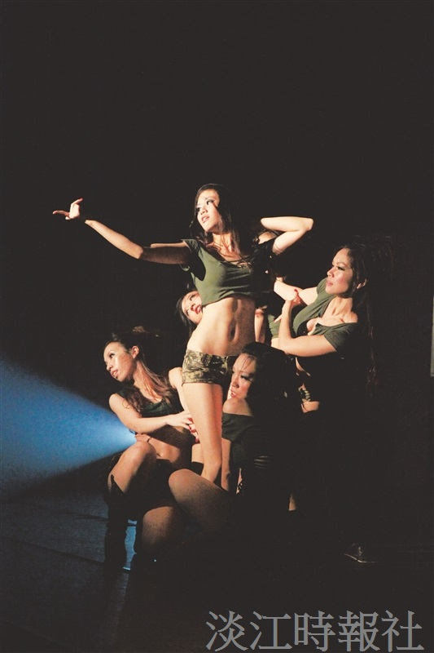
Dancers from the TKU Dance Club dress as soldiers and bedazzle the crowd with their moves.

